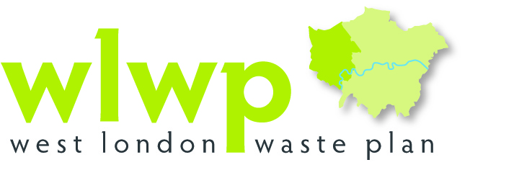

Version for Adoption

March 2015

West London Waste Plan
A Joint Waste Plan for the London Boroughs of Brent, Ealing, Harrow, Hillingdon, Hounslow and Richmond upon Thames
Version for Adoption
March 2015
This is a version of the Plan to be considered for adoption.

Executive Summary
1. For some time, both the European and UK Governments have been concerned that we are sending too much of our waste for disposal – not enough is being recycled and re-used.
2. Consequently, every local authority must produce a plan detailing how it will deal with waste generated in its area over the next 15 years. These plans make up a part of the authority’s Local Plan and show which factors they will take into account when deciding on whether to grant planning permissions for new waste management facilities or extensions and substantive changes to existing ones.
3. In West London, six London Boroughs agreed to co-operate to produce a single waste plan for their combined area. When adopted, this plan will form part of each of their respective Local Plans.
4. Preparation of the West London Waste Plan involved a number of stages and these have included evidence gathering, technical assessment and public consultation. This version of the Plan includes modifications made to the Proposed Submission Plan that underwent independent examination between July 2014 and March 2015 and was found sound by an independent planning Inspector in March 2015.
5. In London, the Mayor set out in the London Plan (adopted in 2011) projections of how much municipal waste and commercial and industrial waste is likely to be generated in the capital over the next 20 years. Each borough was allocated an amount of London’s waste that it is required to positively plan for and manage. This includes ensuring that sufficient capacity is identified to meet the apportioned targets in the London Plan (2011). By each borough meeting its apportionment, London will dramatically reduce its reliance on landfill and move towards being net self-sufficientP overall.
6. The West London Waste Plan:
- details the estimated amounts for the different types of waste that will be produced in West London up to 2031;
- identifies and protects the current sites to help deal with that waste;
- identifies the shortfall of capacity needed over the life of the Plan (to 2031); and
- proposes a set of sites to meet the shortfall which are preferred for waste related development.
7. This Plan has been prepared with the objective of ensuring consistency with national Government policy and general conformity with the London Plan (2011).
8. All policies of this Plan will be taken into account when decisions are made on planning applications for waste development along with any relevant policies in the development plan.
9. The Plan comprises seven sections, covering:
- An introduction to the West London Waste Plan;
- The Vision and Objectives of the Plan;
- How waste is managed at present;
- An explanation of what will be needed in the future to manage waste;
- Details of the sites identified for future waste facilities;
- Policies to guide the determination of planning applications for new waste facilities; and
- An explanation of how the Plan will be monitored in future.
10. The existing sites and additional sites proposed for inclusion in the Plan are set out in the tables below:

Table i: Existing waste sites proposed for allocation
Site Number | Name | Site Area (ha) | Borough
352 | Twyford Waste Transfer Station | 1.24 | Brent
1261 | Veolia Transfer Station, Marsh Road | 2.71 | Brent
309* | Greenford Reuse & Recycling Site | 1.78 | Ealing
310* | Greenford Depot, Greenford Road | 1.78 | Ealing
328# | Quattro, Victoria Road, Park Royal | 0.7 | Ealing
222 | Council Depot, Forward Drive | 2.31 | Harrow
331 | Rigby Lane Waste Transfer Station | 0.91 | Hillingdon
342 | Twickenham Depot | 2.67 | Richmond
Total |  | 12.32
*These two sites are contiguous and part of a larger site: for the purposes of the Plan, they are considered as a single, consolidated site
# This site is subject to a High Speed 2 (HS2) Safeguarding Direction and will not be available from 2017 until 2024

Table ii: Additional sitesS Sallocated in the Plan for waste management uses
Site Number | Name | Site Area (ha) | Borough
2861 | Western International Market | 3.20 | Hounslow
Total |  | 3.20
Combined Total Area = 15.52 hectares

Contents
Executive Summary i
Contents iv
Figures & Tables vi
Maps of Allocated Sites vii
1 The West London Waste Plan 1
1.1 Preparation of the Plan 1
1.2 Why Is The West London Waste Plan Needed? 2
1.3 Relationship with Other Planning Strategies and the Plan’s Status 3
1.4 Sustainability Appraisal and Other Assessments 8
1.5 Community and Stakeholder Consultation 8
1.6 Proposed Submission WLWP 9
1.7 Planning applications for waste management facilities 10
1.8 West London Waste Authority 11
2 Vision and Objectives of the Plan 12
2.1 Vision 12
2.2 Strategic Objectives 12
3 Existing Waste Management 14
3.1 Existing Waste Management 14
3.2 Municipal Solid Waste 14
3.3 Commercial and Industrial Waste 16
3.4 Construction, Demolition and Excavation Waste 16
3.5 Hazardous Wastes 17
3.6 Wastewater and Sewage sludge 18
3.7 Agricultural Waste 19
3.8 Radioactive Waste 19
3.9 Cross boundary Movement of Waste 20
3.10 Role of Landfill in the Management of Residual Waste 22
4 Future Waste Management 24
4.1 How much waste will need to be managed in West London? 24
4.2 How much capacity is needed? 25
4.3 What kind of facilities will be needed? 30
4.4 Construction, Demolition and Excavation Wastes 30
4.5 Hazardous Wastes 31
5 The Sites 32
6 West London Waste Plan Policies 40
6.1 Policy WLWP 1 - Provisions of New Waste Management Capcacity………………40
6.2 Policy WLWP 2 – Safeguarding and Protection of Existing and Allocated Waste Sites 41
6.3 Policy WLWP 3 – Location of Waste Development 42
6.4 Policy WLWP 4 – Ensuring High Quality Development 43
6.5 Policy WLWP 5 – Decentralised Energy 47
6.6 Policy WLWP 6 – Sustainable Site Waste Management 48
6.7 Policy WLWP 7 – National Planning Policy Framework: Presumption in Favour
of Sustainable Development 49
7 Monitoring of the West London Waste Plan 51
8 Glossary 56
9 Appendices 65
Appendix 1: Sustainability Objectives 66
Appendix 2: Existing Waste Sites in West London 68
Appendix 3: Supporting Assessments 72
Appendix 4: General Waste Treatment Facility descriptions 74
Appendix 5: Borough waste arisings and apportionments 75
Appendix 6: Descriptions of Allocated Sites…………………………………………...76
Appendix 7: Relationship between WLWP Plan policies and previously adopted policies in Boroughs' DPDs 103

Figures & Tables
48TFigure 1-1: The West London Waste Plan Area48T 1
48TFigure 1-2: The West London Waste Plan Area context48T 2
Figure 1-3: The Waste Hierarchy………………………………………………………………5
48TFigure 3-1: West London Waste Authority MSW management route (2008 – 2012)48T......15
Figure 3-2: Destination of hazardous waste arisings from West London (2012)…….....18
Figure 3-3: Exports of waste out of West London by management type…………..….…21
Figure 3-4: Where West London sent waste in 2012 by fate & WPA…………….….......22
Figure 4-1: Forecast Arisings and Capacity Apportionment for West London Boroughs from the London Plan (2011)………………………….…………....25
Figure 4-2: Projected Capacity Gap between London Plan (2011) Apportionment and Existing Capacity……………………………………………………………26
Figure 4-3: Interim Capacity Gap between Existing Capacity and Arisings as forecast by the London Plan (2011)…………………………………………... 29
Figure 5-1: Location Plan showing all proposed sites (Policies Map)…….……............ 33

Table 1-1: Recycling/composting/reuse targets set in the London Plan (2011) 2
Table 1-2: Timetable for the development of the West London Waste Plan 3
Table 3-1: West London Waste Authority management of MSW (2011-2012)………….15
Table 3-2: Management of CD&E waste in West London…………………………………17
Table 3-3: Principal Flows of Waste out of West London 2012………………………..…20
Table 3-4: Waste sent to Landfill from West London in 2012, by receiving site type…..23
Table 4-1: Quantity of MSW and C&I waste forecast to be produced in West London & the apportionment figures from the London Plan (2011) for target years 24
Table 4-2: West London Capacity Requirements for Target Years based on the London Plan (2011) 27
Table 4-3 Contribution of allocated sites to meet the London Plan apportionment……..28
Table 5-1: Existing waste sites considered to have potential for redevelopment 34
Table 5-2: Additional sites with opportunity for developing waste facilities……………...39
Table 7-1: Monitoring programme for the West London Waste Plan 53

Maps of Allocated Sites
Site 352 Twyford Waste Transfer Station, Abbey Road, Brent……………………...….35
Site 1261 Veolia Transfer Station, Marsh Road, Alperton, Brent………………………...35
Site 309 Greenford Reuse and Recycling Site & Site 310 Greenford Depot, Greenford Road, Greenford, Ealing…………………………………………..….36
Site 328 Quattro, Victoria Road, Park Royal, Ealing……………………..……………....36
Site 331 Rigby Lane Waste Transfer Station, Hayes, Hillingdon…………………….... 37
Site 342 Twickenham Depot, Langhorn Drive, Twickenham, Richmond……………....37
Site 222 Council Depot, Forward Drive, Harrow……………………………………….....38
Site 2861 Western International Market, Hayes Road, Southall, Hounslow………...….39

The West London Waste Plan

1.1 Preparation of the Plan
    - The West London Waste Plan has been prepared jointly by the six West London Boroughs of Brent, Ealing, Harrow, Hillingdon, Hounslow and Richmond upon Thames. The area covered by the plan, and how it is split into its constituent boroughs is shown in Figure 1-1. How the West London Waste Plan area sitSeSs within its wider regional context is illustrated at Figure 1-2.

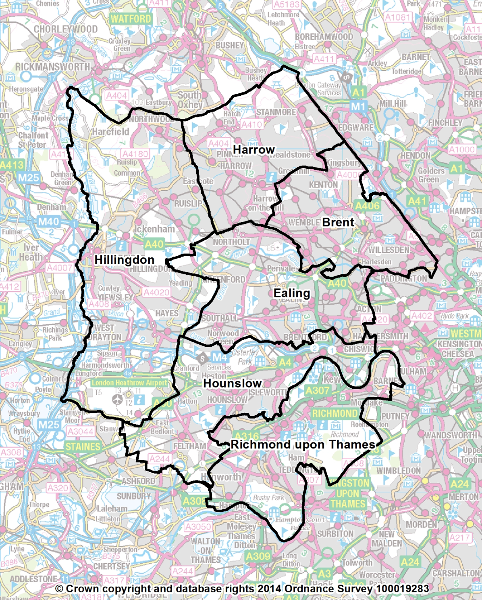
Figure 1-1: The West London Waste Plan Area
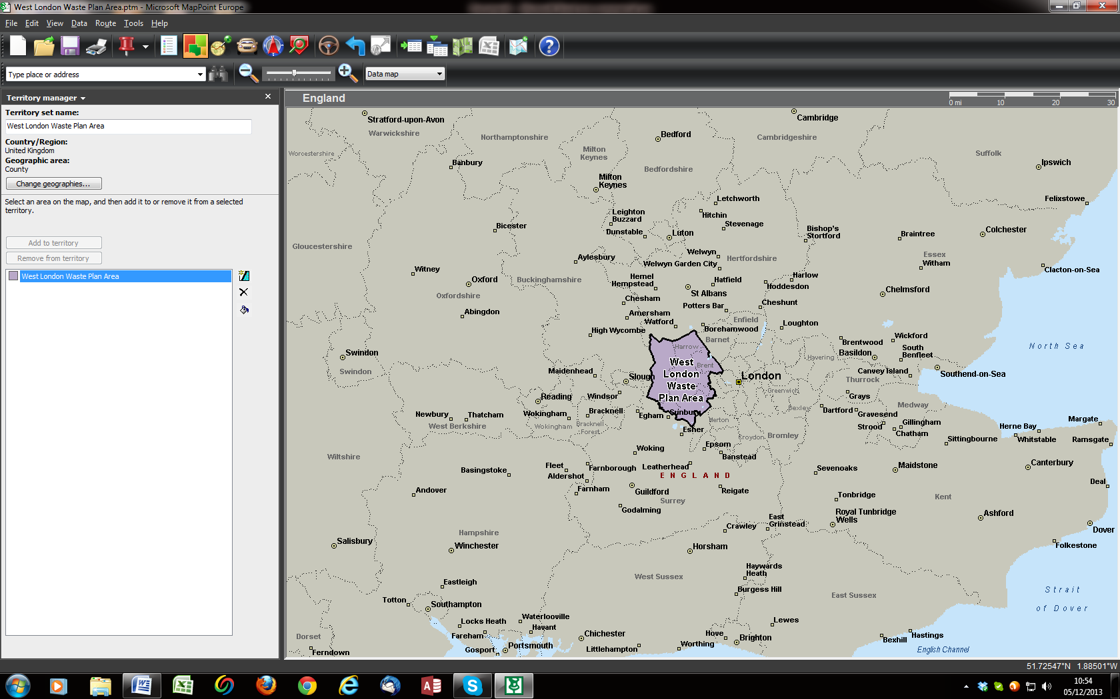
Figure 1-2: The West London Waste Plan Area context

1.2 Why Is The West London Waste Plan Needed?

1.2.1 The West London Waste Plan (the Plan) provides a planning framework for the management of all waste produced in the six Boroughs over the period to 2031. The Boroughs are required by Government to prepare local planning policy for waste management which needs to be in general conformity with the Mayor’s London Plan. The London Plan is the Mayor of London’s planning strategy for the capital that sets out targets for recycling and composting for waste from households, businesses and industry (See Table 1-1 below). At the time of preparation of this Plan the London Plan (2011)PP was in force. The London Plan has been updated by the ‘Further Alterations to the London Plan’ (FALP) which were adopted by the Mayor in March 2015. This Plan reflects the targets and waste apportionments specified in the 2011 version. The Boroughs have committed to reviewing this Plan in light of FALP adoption.
Table 1-1: Recycling /composting/reuse targets set in the London Plan (2011)
Waste stream | 2015 | 2020 | 2031
Municipal Solid Waste | 45% | 50% | 60%
Commercial & Industrial Waste | - | >70% | -
Construction, Demolition & Excavation | - | >95% | -
Diversion of biodegradable/recyclable wastes from landfill | - | - | 100%
Source: London Plan (2011)

1.2.2 A significant amount of waste is transferred outside of London for treatment or disposal. The London Plan (2011) aims to ensure that as much of London’s waste is managed within London as practicable working towards managing the equivalent of 100% of London’s waste within London by 2031.

1.2.3 The West London Waste Plan will form part of the Development Plan for each of the Boroughs and the Old Oak Common and Park Royal Development Corporation (which covers part of Brent and Ealing). This Plan supersedes certain policies in other Borough Development Plan Documents as set out in Appendix 7. The Development Plan comprises a number of development planning documents containing both specific policies for waste and sites identified for waste management. These planning documents must be in general conformity with the London Plan and pay regard to national policies and advice. Before the Plan can be adopted the independent Inspector has to find that it has been prepared in accordance with the Duty to Co-operate; that it satisfies legal and procedural requirements; and that it is sound.

1.2.4 This Plan identifies the sites proposed for waste management development in the plan area and provides policies with which planning applications for waste developments must conform. This Plan reflects the London Plan (2011) apportionment targets providing management of waste from households, business and industry in the Plan area up to 2031. The timetable for the production of the Plan and for its final adoption is shown in Table 1-2.
Table 1-2: Timetable for the development of the West London Waste Plan
Period | Stage of development
January - March 2009 | Issues and Options Consultation
February - March 2011 | Proposed Sites and Policies Consultation
March - April 2014 | Proposed Submission Consultation
July 2014 | Submission to the Secretary of State c/o Planning Inspectorate
Autumn 2014 | Public Examination
Summer 2015 | Adoption by the West London Boroughs

1.3 Relationship with Other Planning Strategies and the Plan’s Status
1.3.1 The Plan is influenced by, and has to give consideration to, relevant European, national, regional and local policy in relation to waste development (both adopted and emerging). The Plan supports the implementation of the Boroughs’ Sustainable Community Strategies in several ways which follow the three pillars of sustainable development, which underpin the Sustainable Community Strategies, as follows:
– Social: The Plan ensures that waste is managed in a way that protects communities and their health;
– Environmental: The Plan ensures that waste will be managed in a manner that does not harm the environment
– Economic: The Plan seeks to provide sufficient opportunities for the management of waste that is an essential part of a high performing economy.

1.3.2 Once this Plan is adopted by each of the constituent boroughs it will take on the status of a statutory Local Development Document, and form part of the Development Plan. Determination of planning applications shall be made in accordance with the Development Plan unless material considerations indicate otherwise.
European Legislation
1.3.3 The revised Waste Framework Directive [2008/98/EC]PP, which has been implemented by the Waste (England and Wales) (Amended) Regulations 2012PP, is the over-arching European Union (EU) legislation for waste. The directive requires Member States to take appropriate measures to encourage firstly, the prevention or reduction of waste and its harmfulness and secondly, the recovery of value from waste by means of recycling, re-use or reclamation or any other process with a view to extracting secondary raw materials, or the use of waste as a source of energy. This management scheme is called the waste hierarchy (see Figure 1-3), and the objective is to manage waste as near to the top of the hierarchy as possible with safe disposal of waste as a last resort. Article 28 of the Directive also requires Member States to prepare one or more waste management plans that cover its entire geographical area. Insofar as waste local plans are concerned, the key provisions relate to the waste hierarchy; protection of human health and the environment; the principles of proximity and self-sufficiency; the establishment of waste management plans; and periodic inspections.

1.3.4 The West London Waste Plan provides for the management of waste according to the waste hierarchy (Figure 1-3 below).

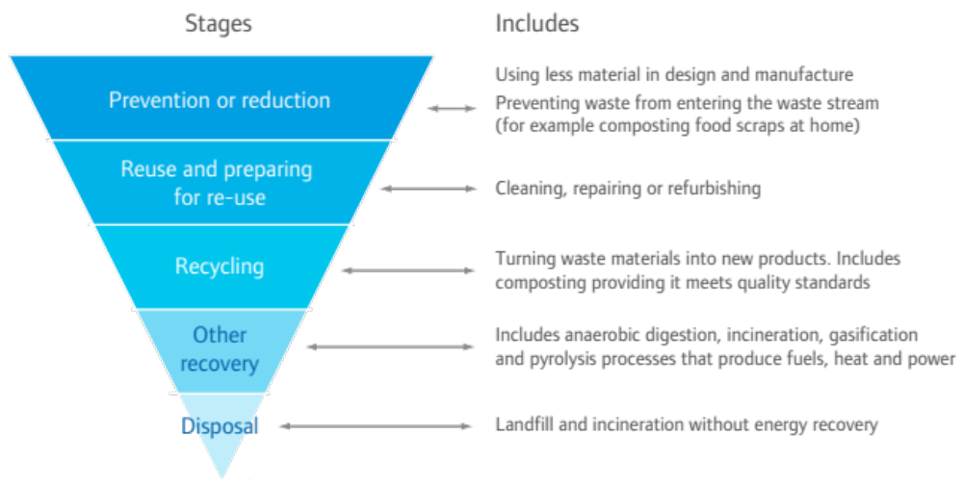

Figure 1-3 The Waste Hierarchy

National Policy
1.3.5 The planning system, as well as the waste management industry has undergone significant changes over the past few years. The National Planning Policy Framework (March 2012) sets out the national policy approach to ensuring sustainable development but does not include policy concerned specifically with the management of waste.
National Planning Policy for Waste
1.3.6 National Planning Policy for WastePP sets out national objectives and guidance to be considered when producing planning policies for waste development and consideration of applications for waste development and for development that have waste management implications.
Waste Management Plan for England
1.3.7 To meet the requirement of the Waste Framework Directive for a national waste plan, in December 2013, the Government published an updated waste strategy for England in the form of a National Waste Management Plan (known as the ‘Waste Management Plan for England’ December 2013) along with a separate National Waste Prevention Plan. Production of local waste plans is also intended to contribute towards meeting this requirement.
1.3.8 Publication of the Waste Management Plan for England followed ‘The Government Review of Waste Management Policy in England 2011’PP which was published following a comprehensive review of The Waste Strategy for England 2007. The Waste Management Plan for England provides an overview of waste management in England and fulfils Article 28 of the Waste Framework Directive mandatory requirements, and other required content as set out in Schedule 1 to the Waste (England and Wales) Regulations 2011.
Localism Act 2011 and the Duty to Co-operate
1.3.9 The Localism Act 2011 provides for the abolition of all Regional Spatial Strategies (RSSs), except the London Plan (2011) which is retained in the capital. The RSSs apportioned quantities of waste to be managed in each sub-regional area which generally corresponded to a Waste Planning Authority (WPA) area. WPAs outside London are no longer required to be in conformity with the now abolished RSSs or meet waste management apportionments for London. In the South East and East of England, this included provision for landfill of some residual waste from London. This means that some counties that previously considered West London’s residual waste management needs when planning landfill capacity may no longer be doing so. Clearly this has a significant implication for the management of waste from London boroughs where waste is exported to be managed outside the London area. The London Plan (2011) expects London boroughs to plan for 100% net self-sufficiency in waste management by 2031, whilst recognising that there is likely to be ongoing management of waste arising in London outside of the capital, albeit in decreasing amounts.

1.3.10 The Localism Act 2011 introduced the ‘Duty to Co-operate’ requiring local planning authorities (and other public bodies) to co-operate in relation to the planning of sustainable development. All public bodies have a duty to co-operate on planning for strategic matters that have cross administrative boundary impacts. The NPPF notes the need for co-operation on strategic prioritiesPP such as the provision of infrastructure for waste management and wastewater. In carrying out their duty, the Act expects bodies to “engage constructively, actively and on an ongoing basis”. In the case of West London the particular cross boundary movements of waste considered are as follows:
- Management of residual waste
- Management of hazardous waste

1.3.11 The extent of these movements is detailed in Section 3. In considering this, the West London boroughs have engaged formally with the Environment Agency as well as relevant WPAs. Contact was made with all WPAs currently accepting waste from the Plan area. Emails, meetings and telephone conversations were used to exchange and confirm information on waste flows between areas and to agree significant cross boundary issues regarding the waste flows, future requirements and other, related matters. Attendance at meetings of regional groupings of Waste Planning Authorities such as the London Regional Technical Advisory Board (RTAB) and the South East Waste Planning Advisory Group (SEWPAG) provided further opportunities to discuss cross boundary issues.

1.3.12 Published and emerging waste planning documents of the counties concerned were also consulted to assess current and projected capacities and policies regarding accepting waste from West London in the future.

1.3.13 Throughout the Plan process there has been ongoing engagement with other WPAs.

1.3.14 Details of how the West London Boroughs engaged with bodies to meet the Duty to Co-operate requirements are contained in a separate Duty to Co-operate ScheduleS.
Regional Policy

1.3.15 The London Plan provides the regional planning framework for the six West London Boroughs jointly preparing the Plan and outlines the principal guidelines for waste development. The Government has agreed that, although Regional Spatial Strategies (RSS) for other parts of England have been revoked, the London Plan will continue to provide strategic guidance for the capital, as part of the Development Plan.

1.3.16 This Plan is in general conformity with the policies in the London Plan and in particular those regarding waste management. As mentioned above, this includes an apportionment of the tonnages of municipal and commercial and industrial waste to be managed by each London borough; revised targets for recycling of municipal waste; and new targets for recycling of commercial and industrial waste and recycling or reuse of construction and demolition waste and diversion of waste from landfill (see Table 1-1).

1.3.17 Implementation of the policies in this Plan will ensure that the Boroughs contribute towards the London Plan aim of net self-sufficiency by 2031.

1.3.18 In March 2015 the Mayor adopted Further Alterations to the London Plan (FALP). These include amendments to the forecast quantities of commercial and industrial waste arising within London, based on baseline data adjusted down to reflect the findings of the national C&I waste survey of 2010. As a consequence the revised projected overall capacity shortfall identified has fallen and hence the revised Borough apportionment targets have reduced. The need for changes to this Plan in light of the FALP will be considered in due course.

Local Policy

1.3.19 Each borough must produce a Local Plan which replaces what was previously called the Local Development Framework or Unitary Development Plan. The Local Plan includes policies, strategies and plans, such as this Plan, and may comprise more than a single document.

1.3.20 This Plan has been prepared jointly by the six West London Boroughs, and is aligned with their individual Local Plans and helps deliver their Sustainable Community Strategy.

1.4 Sustainability Appraisal and Other Assessments

1.4.1 The Plan has been subjected to a Sustainability Appraisal (SA) during the course of its development. An SA appraises whether planning documents accord with the principles outlined in the Government’s UK Sustainable Development agendaPP and implements the EU Strategic Environmental Assessment Directive. The SA aims to ensure that sustainability considerations are taken into account early in the process of policy development.

1.4.2 A Habitats Regulations Assessment (HRA); an Equalities Impact Assessment (EqIA) and a Strategic Flood Risk Assessment (SFRA) have also been undertaken as part of the development of this Plan. Appendix 2 provides details on the processes followed for each of these assessments.

1.5 Community and Stakeholder Consultation
1.5.1 The West London Waste Plan has been informed by consultation with statutory bodies, local organisations, key stakeholders and the wider community throughout its preparation. This has been carried out in accordance with each borough’s “Statement of Community Involvement”. Initial consultation took place in January and February 2009 on the key issues which the West London Waste Plan needs to address, as set out in the West London Waste Plan Issues and Options reportPP. A wide range of responses was received at various public workshops and meetings held across the six Boroughs, and by written representations.
1.5.2 The Boroughs’ preferred approach to deal with the issues raised, as well as a list of the proposed sites, was published for comment in February 2011 in the Proposed Sites and Policies reportPP. Staffed drop-in sessions in each of the six Boroughs were attended by over 120 people, with 64 people attending further meetings. In addition to responses received at these events, 248 questionnaires were completed, and a further 133 additional written and email submissions were made. Two petitions containing 2,399 signatures were also submitted. A summary report on this consultation is available on the West London Waste Plan website (www.wlwp.net).

1.6 Proposed Submission WLWP

1.6.1 Representations were received on the Proposed Submission draft of the West London Waste Plan, including the Sustainability Appraisal and Equalities Impact Assessment during a six week period between 28 February and 11 April 2014.

1.6.2 All representations (which were not withdrawn) were submitted for consideration by a Planning Inspector at a formal examination. The purpose of the examination was to consider whether the Waste Plan complies with the legal and procedural requirements and is ‘sound’.

1.6.3 Since the Planning Inspector’s purpose is to answer these questions, the representations relate to legal compliance and “soundness”, as set out in the National Planning Policy Framework, 2012 (NPPF). This includes being prepared in accordance with the Duty to Co-operate.

1.6.4 In summary, for this Plan to have been found 'sound' it passed the following tests:
- Positively prepared – the plan should was prepared based on a strategy which seeks to meet objectively assessed development and infrastructure requirements, including unmet requirements from neighbouring authorities where it is reasonable to do so and consistent with achieving sustainable development;
- Justified – the plan is the most appropriate strategy, when considered against the reasonable alternatives, based on proportionate evidence;
- Effective – the plan is deliverable over its period and based on effective joint working on cross-boundary strategic priorities; and
- Consistent with national policy – the plan enables the delivery of sustainable development in accordance with the policies in the National Planning Policy Framework.

1.6.5 More guidance on the meaning of these terms is available from the Planning InspectoratePP and in the National Planning Policy Framework, 2012PP which outlines the requirements for Local Plans and the National Planning Policy for Waste which provides specific guidance for planning for sustainable waste management.
Public Examination
1.6.6 Following submission, the Secretary of State appointed a Planning Inspector to hold an independent examination of the Plan. This examination included public hearings which took place between 7 and 10 October 2014.

1.6.7 Further information can be obtained via the website:
www.wlwp.net

1.6.8 The West London Waste Plan document and an accompanying, Sustainability Appraisal and Equalities Impact Assessment are available for download via the West London Waste Plan website at: 48Twww.wlwp.net48T. Hard copies are also available to view at:
- All Libraries across the six Boroughs; and
- Local Council Offices across the six Boroughs.
1.6.9 All other submission documents, including the evidence base, are available for download. The West London Boroughs will seek to ensure that all reports are accessible to everyone and will offer assistance to those who are blind or partially sighted or do not speak English fluently.

1.7 Planning applications for waste management facilities

1.7.1 Once adopted, the West London Waste Plan will be the primary policy framework against which planning applications for waste management facilities in the West London Boroughs will be assessed. In the first instance developers should use the plan to guide them in identifying suitable sites to accommodate new waste management facilities. These site allocations are also supplemented by development management policies which provide a framework to assess the acceptability of individual proposals. Developers should also consider requirements and policies within the following documents before submitting a planning application for a waste management facility in West London:
- National policy and guidance, including that relating to waste management;
- Borough Local Development Documents;
- London Plan;
- 0TMayor of London Order (2008); and
- Supplementary Planning Guidance from the Mayor or relevant Supplementary Planning Documents from the Boroughs.
1.7.2 Certain types of waste development need to be referred to the Mayor. Under the Mayor of London Order (2008) the Mayor has powers to take a decision on the following types of waste development applications as follows:
- Waste development to provide an installation with capacity for a throughput of more than 5,000 tonnes per annum of hazardous waste, 50,000 tonnes per annum of waste or occupying more than one hectare.
- Waste development that does not accord with one or more provisions of the Local Plan (including this Plan once adopted) and either occupies more than 0.5 hectares or has capacity for more than 20,000 tonnes per annum of waste or 2,000 tonnes per annum of hazardous waste.

1.8 West London Waste Authority

1.8.1 The West London Waste Authority (WLWA) is the statutory Waste Disposal Authority for the six West London Boroughs and as such is solely responsible for the transport, treatment and disposal of municipal solid waste (MSW) collected by the Boroughs. The WLWA is not responsible for Commercial and Industrial Waste (C & I), Construction, Demolition and Excavation Waste (CD & E) or forms of non-municipal hazardous waste.

1.8.2 The WLWA and its constituent Boroughs consulted on and subsequently adopted a Joint Municipal Waste Management StrategyPP in 2005. The strategy sets out the future waste and recycling plans and targets for the Authority and each of the six Boroughs to 2020. This was updated in 2009.

2 Vision and Objectives of the Plan

2.1 Vision

2.1.1 The unique characteristics of West London, as well as the key challenges and opportunities that have been identified in developing the Plan, have fed into the vision of the Plan, which is supported by its aims and objectives.
West London Waste Plan Vision
Over the period to 2031, the West London Waste Plan area will have made provision for enough waste management facilities of the right type and in the right locations to provide for the sustainable management of waste guided by the waste hierarchy to achieve net self-sufficiency and meet the needs of local communities. It will seek to do so, in a progressive manner, whilst protecting the environment, stimulating the economy and balancing the needs of West London’s communities.

2.1.2 The vision of the Plan sets out how the Boroughs wish to see waste managed in West London by 2031. Its formulation has been informed by national, regional and local guidance along with the views of key stakeholders and the evidence base that underlies the Plan.

2.2 Strategic Objectives

2.2.1 The West London Waste Plan strategic objectives underpin the achievement of the vision and were developed in response to the key issues for West London and responses received through community consultation.
West London Waste Plan Strategic Objectives
- To identify sufficient land for the management of the six Boroughs’ pooled waste apportionment as set out in the London Plan (2011), including safeguarding existing waste sites and maximising their use as waste management sites and to provide for the sustainable management of an amount of waste equivalent to the amount arising within the Plan Area.
- To ensure that waste is managed as far up the waste hierarchy as possible, by encouraging the minimisation of waste and the use of waste as a resource.
- To reduce the impact of waste management on climate change by encouraging the use of sustainable transport and new, clean technologies, whilst seeking to locate waste management facilities as close to waste sources as practicable.
- To ensure that, through appropriate policies, waste facilities meet the highest standards possible of design, construction and operation to minimise adverse effects on local communities and the environment.
- To support the key aims and objectives of Brent, Ealing, Harrow, Hillingdon, Hounslow and Richmond’s Sustainable Community Strategies.

3 Existing Waste Management

3.1 Existing Waste Management

3.1.1 West London produces, and is expected to continue to produce, a significant quantity of waste. This section looks at the different types of waste being generated in West London and how it is currently being managed, along with future trends allowing for the West London Boroughs to determine what polices and sites are needed that will facilitate the development of the sustainable infrastructure required to meet the London Plan (2011) waste apportionment figures (Table 4-2) and net self sufficiency. The main types of waste produced include:
- Municipal Solid Waste
- Commercial and Industrial Waste
- Construction, Demolition & Excavation Waste
- Hazardous Waste
- Wastewater and Sewage Sludge

It should be noted that the London Plan (2011) apportionment targets are for municipal and commercial & industrial wastes, including the hazardous element of both, only.

3.2 Municipal Solid Waste

3.2.1 Municipal Solid Waste (MSW) in the West London Boroughs is managed by the WLWA and includes household waste, kerbside collected recyclables, green waste and waste and recyclables collected at household waste recycling centres.

3.2.2 As the statutory body responsible for managing MSW generated in the West London Boroughs, the WLWA has in place long term contracts for the management of this waste. The main objective of the contracts is to end the landfilling of residual municipal waste. The contracts involve the management of up to 390,000 tonnes of MSW per year.P
3.2.3 Since 2008 there has been a steady decline in MSW sent to landfill from the Plan area, both in terms of the total tonnage sent and the percentage this represents of the area's total waste stream. Figure 3-1 below uses financial year data since 2008 and shows the different waste management routes used for the MSW stream. Note that the material initially sent to Materials Recovery Facilities (MRFs) is then sent on for management via other waste management routes.
Figure 3 – 1 West London Waste Authority MSW management (2009 – 2012)
Financial years

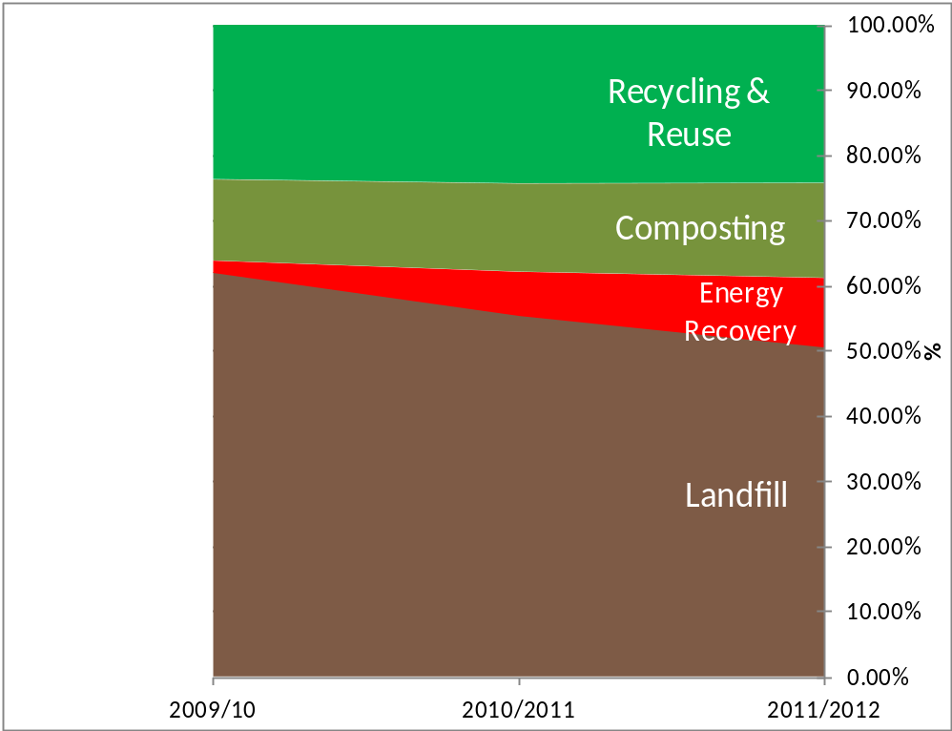

Source: WLWA

3.2.4 In 2012 the WLWA and its constituent Boroughs dealt with around 657,000 tonnes of MSW, excluding abandoned vehicles. Of this total some 154, 000 tonnes was recycled, 90,000 tonnes was composted, and 93,000 tonnes was sent to MRFs from which waste went on to other routes. Ultimately, 413,000 tonnes was sent either to Energy from Waste (EfW) or to landfill sites in Oxfordshire and Buckinghamshire (just over 80% by rail from the WLWA’s transfer stations in Brentford and South Ruislip). See Table 3-1 below.
Table 3-1: WLWA management of Municipal Solid Waste 2012S
Calendar year (tonnes rounded to nearest 000 and percentages rounded)
Municipal Solid Waste management | Tonnes | Percentage
Recycling | 154,000 | 23
Composting | 90,000 | 14
Energy from Waste | 117,000 | 18
Landfill | 296,000 | 45
TOTAL | 657,000 | 100

3.2.5 From 2009/10 increasing quantities of waste, not recycled or composted, have been diverted from landfill by sending it to EfW. The WLWA has a contract to send residual waste to the Lakeside Energy from Waste plant near Slough, until 2034/35. This contract has an annual tonnage of 25,000 tonnes until 2014/15 when for one year the tonnage increases to 45,000 tonnes. The following year (2015/16) the tonnage increases to 90,000 tonnes and remains at that level until the final year of the contract. In addition materials sent to certain MRFs in the Plan area are then sent to recycling, EfW and landfill respectively. The tonnages of these outputs are included in Table 3-1 and Figure 3-1 above (by financial year). This illustrates how the dominance of landfill has been broken by use of other management routes so that less than 50% of waste managed by the WLWA was actually landfilled in 2012 (calendar year).

3.3 Commercial and Industrial Waste

3.3.1 The most recent and comprehensive national Survey of C&I waste arisingsPP took place in 2009. This survey estimated that West London produced 845,000 tonnes of C&I waste during that year, which is a reduction of 621,000 tonnes (42%) on the previous C&I Survey conducted in 2002/03 (this estimated that 1,466,000 tonnes of C&I waste was produced). Work carried out to underpin the London Plan (2011)'s apportionment targets has estimated that West London produced 1,299,000 tonnes of C&I waste in 2009 and for the purposes of consistency, this estimate has been used in the Plan. However the proposed Further Alterations to the London Plan (FALP) propose aligning the C&I waste baseline and forecasts with the national survey results. If the FALP is adopted as proposed, this would mean a significant fall in projected arising of this waste stream.

3.4 Construction, Demolition and Excavation Waste

3.4.1 A detailed study of arisingsPP has been undertaken which estimated that just over 3 million tonnes of Construction, Demolition and Excavation waste (CD&E) waste is produced in West London each year. This is managed at sites within and beyond West London. This estimate is based on consideration of previous national surveys and analysis of data within the most recent Environment Agency Waste Data Interrogator (EA WDI).

3.4.2 According to the EA WDI 2012, around 776,000 tonnes of CD&E was imported for management at facilities within West London in 2012. This estimate is based on an analysis of waste managed at sites permitted for the management of waste by the Environment Agency, and does not account for aggregate production nor uses of CD&E in development (e.g. as an engineering material) which are exempt from the need for a permit. Table 3-2 below shows the management of CD&E waste in West London based on 2012 data from the EA Waste Data Interrogator.

Table 3-2 Management of CD&E waste in West London 2012
 | CD&E Arising in West London | CD&E Imported into West London | Total
Managed at permitted sites within West London | >331,000 | 776,000 | 1.107million
Managed at permitted sites beyond West London | 411,000 | N/A | N/A
Total | 742,000 | N/A | N/A
Source: EA Waste Data Interrogator 2012

3.5 Hazardous Wastes

3.5.1 Hazardous wastes are categorised as those that are harmful to human health, or the environment, either immediately or over an extended period of time. They range from asbestos, chemicals, and oil through to electrical goods and certain types of healthcare waste. A detailed study of arisingsP P has been undertaken which found the following:
- In 2012, West London produced just over 88,000 tonnes of which approximately 85% was exported for management.
- At the same time 20,000 tonnes was imported from outside the Plan area.
- Overall the Plan Area achieved 40% net self sufficiency in 2012.
- Hazardous waste requires a range of specialist facilities for treatment and disposal, but it is not anticipated that substantial additional need for new capacity locally will arise and so land allocations specifically for the development of additional hazardous waste management capacity have not been identified in this Plan.

Figure 3-2 - Destination of hazardous waste arisings from West London (2012)
Increasing intensity of colour corresponds to increasing tonnage sent. 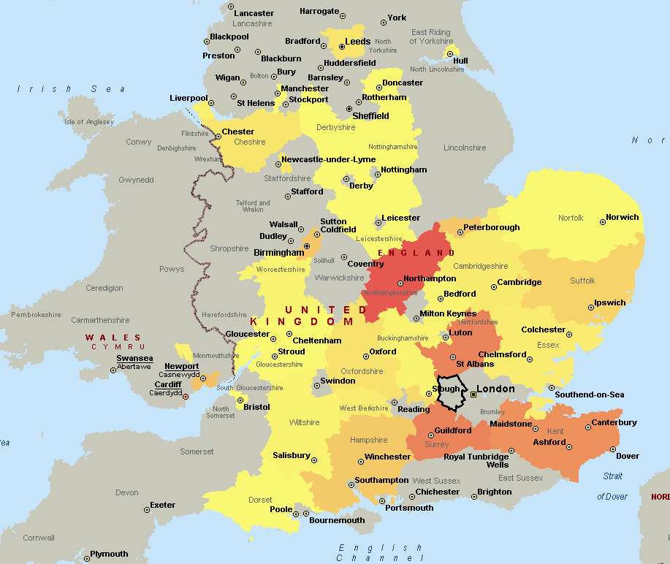
Source: EA Hazardous Waste Interrogator (HWI) 2012 & EA Waste Data Interrogator 2012

3.5.2 In 2012, West London Boroughs exported hazardous waste to 38 different destinations across England, with the main ones being Northamptonshire, Hertfordshire, Surrey and Kent. The primary destinations of hazardous waste exported out of London generated in West London are shown in Figure 3-2 above.

3.6 Wastewater and Sewage sludge

3.6.1 Thames Water Limited is responsible for wastewater and sewage sludge treatment in London and, as part of this responsibility, it manages key pieces of sewerage infrastructure, including a number of sewage treatment works (STW). The majority of wastewater in West London is either treated at Mogden STW in Isleworth, Beckton STW in East London. During 2010, these facilities generated over 100,000 tonnes of sewage sludge (dry solids) with all of this sludge being recovered in some way either through incineration with energy recovery, recycled to agricultural land or used for land restoration.

3.7 Agricultural Waste
3.7.1 The Environment Agency Waste Data Interrogator (WDI) indicates that in 2012, a total of 7, 236 tonnes of waste from agricultural sources (EWCPP chapter 02 01) in West London was managed at waste management sites with Environmental Permits reporting through the WDI 99% of this was managed through treatment. However this figure doesn't include waste types which are known to be produced on farms recorded in the WDI under other waste codes. The main types of this type of waste include:

- Agricultural packaging such as plastic film;
- End of Life vehicles such as tractors;
- Tyres; and
- Asbestos construction waste.

Nor does it include waste managed through routes other than permitted sites. However, in light of the predominantly urban character of the Plan area there are limited opportunities for the production of this waste stream and so its management is not considered to be an issue needing specific consideration in this Plan.

3.8 Radioactive Waste

3.8.1 Limited information is available regarding the generation of radioactive waste in West London, with no arisings records held by either the Environment Agency or the Department of Energy and Climate Change. A detailed study of arisingsPP has been undertaken which found the only identified sources that may generate small amounts of low level radioactive waste (LLW) and very low level radioactive Waste (VLLW) are at 21 locations across the Boroughs including hospitals, universities, research facilities and a few commercial operations.
3.8.2 Most radioactive waste produced by minor waste producers is not reported in the UK Inventory as it is either low volumes of LLW that can be disposed of by “controlled burial” at landfill sites under special licence, or low volume VLLW that is disposed within the MSW and C&I waste streams. As separate recording of VLLW production or management is not required it is not possible to quantify how much is managed from the Plan area. It is possible that some VLLW is managed at the Hillingdon clinical waste incinerator along with other wastes. The nearest available landfill accepting LLW is a nationally strategic site in Northamptonshire. In addition a High Temperature Incinerator in Fawley, near Southampton has some capability to deal with these types of waste. These facilities are preferred for use than sending it to the national LLW disposal facility near Drigg, Cumbria.

3.8.3 There is no apparent market appetite or demand for a LLW management facility to be developed in the Plan area and so the practice of exporting those quantities that may be produced for management elsewhere is likely to continue. In light of this, the Plan does not include specific policies to cover such development.

3.9 Cross boundary Movement of Waste

3.9.1 Whilst around 1 million tonnes of West London's own waste is managed within West London Boroughs, waste also moves into and out of the Plan area for management. It is important to assess the level of this cross boundary movement of waste and to identify potential implications for the West London Waste Plan during the Plan period, particularly to meet the ‘Duty to Co-operate’.
 | Tonnes | Principal Destination | Principal Management Route
Municipal Solid Waste  (from WDF) | 415,000 | Bucks (35%)  Oxon (33%)  Slough (24%) | Landfill  Landfill  EfW
Commercial and Industrial Waste (from WDI +) | 537,000 | Bucks (33%)  M Keynes (32%)  Slough (15%)  LB Southwark (6%)  LB Bexley (5%)  Herts (4%)  NLWP (3%)  Surrey (1%) | Landfill  Landfill  Co-Incineration  Treatment  Treatment  Landfill  Treatment  Landfill
Construction, Demolition and Excavation Waste (from WDI) | 412,000 | Bucks (26%)  M Keynes (24%)  Slough (19%)  Herts (11%)  LB Greenwich (7%)  NLWP (5%)  Surrey (5%)  Oxon (4%) | Landfill  Landfill  Landfill  Landfill  Treatment  Treatment  Landfill  Landfill
TOTAL | 1.36 million

Table 3-3: Exports of waste out of West London by management type, 2012

NB: CD&E value excludes substantial quantities managed through activity that do not require permits

3.9.2 Around 1.3 million tonnes of West London's waste were exported out of London in 2012. This comprises Municipal Solid Waste (MSW), Commercial and Industrial Waste (C & I), Construction, Demolition and Excavation Waste (C, D & E) and certain types of hazardous waste. A proportion of this waste is handled by the WLWA. Table 3-3 above shows the level of exports or flows out of the West London area.
3.9.3 Landfill accounted for less than three quarters of the movements of all waste out of the Plan area in 2012 as shown in Figure 3-3 below which while varying from year to year is following a reducing trend.

Figure 3-3: Exports of waste out of West London by management type, 2012

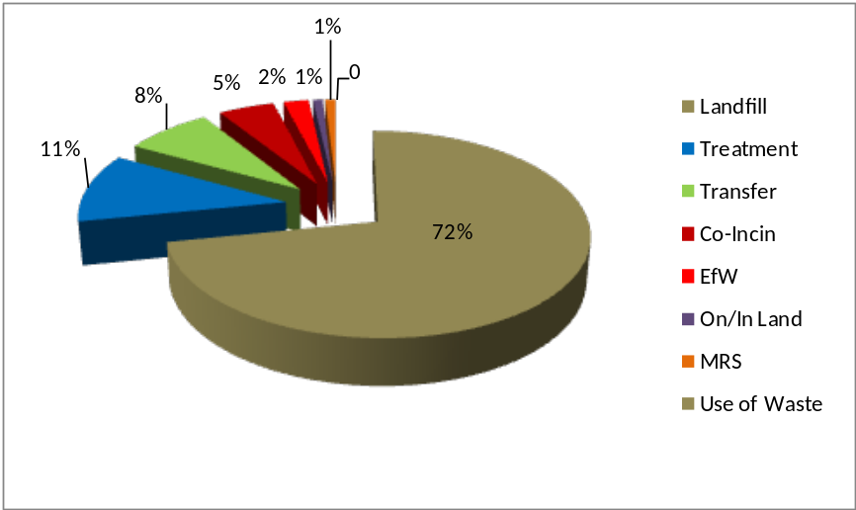

Source: WDI 2012

3.9.4 Figure 3-4 illustrates that the majority of waste exported in 2012 was sent to Buckinghamshire (31%), Milton Keynes (20%), Slough (19%) followed by Oxfordshire (11%) with the bulk of the remaining 19% divided between 6 other authorities. This has changed significantly from previous years when Bedfordshire received substantial quantities of waste for landfilling (just under 200,000 tonnes in 2011).

3.9.5 A high level totalling exercise of WDI 2012 data alone indicates that of the 2.37 million tonnes of waste received by permitted sites in West London from within the capital, up to 1.3 million tonnes comes from outside West London. This compares with 132,000 tonnes of waste from West London managed within the rest of London, which is only 10% of quantity of waste imported from London into West London. This demonstrates the significant contribution facilities within West London already make to the management of London's waste and overall target of achieving net self sufficiency by 2031.

Figure 3-4: Waste sent for management to any type of facility beyond the Plan area
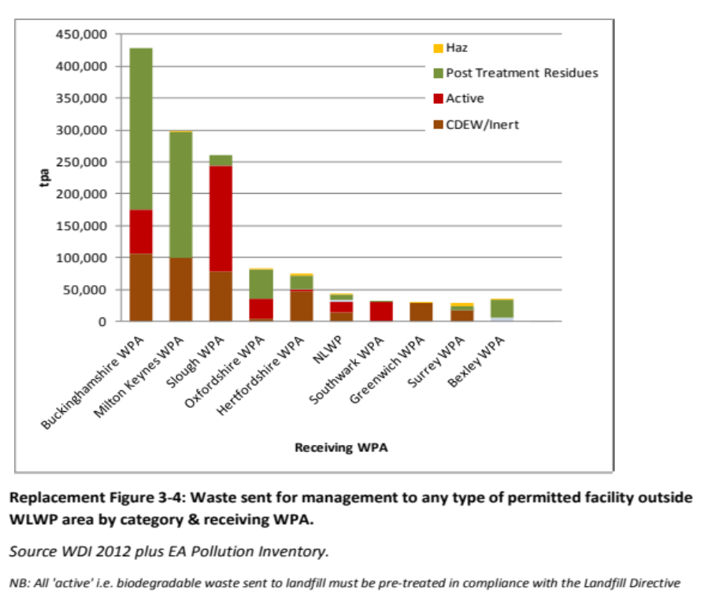
NB: All ‘active’ i.e. biodegradable waste sent to landfill must be pre-treated in compliance with the Landfill Directive
Source: WDI 2012 plus EA Pollution Inventory

3.10 Role of Landfill in the Management of Residual Waste
3.10.1 Landfill disposal accounted for approximately 1,143,000 tonnes of waste arising in West London in 2012, with 90% of that exported to landfill facilities outside of the Plan area. The remaining 107,400 tonnes was managed at Harmondsworth Landfill located in southwest Hillingdon.

3.10.2 There are several different types of landfill, all of which play a different role in helping to manage waste from West London. Generally these are categorised by the types of waste they can accept for disposal. Table 3-4 below shows the types and amounts of waste sent to landfill from West London in 2012

3.10.3 Non-hazardous landfill usually receives residual MSW and C&I waste plus inert CD&E waste that is used for engineering and operational purposes, whereas Inert Landfill only receives inert waste from the CD&E waste stream. Hazardous waste landfills are highly specialised and only accept certain hazardous waste, while stable, non-reactive hazardous waste (SNRHW) (e.g. asbestos) sent to non-hazardous landfill can be deposited in an area specifically designed to accept SNRHW isolated from biodegradable waste.

Table 3-4 Waste sent to landfill from West London in 2012, by receiving site type
Type of waste received by site | Tonnes
Hazardous (SNRHW) via Separate Cell | 5,459
Non Hazardous | 1,079,915
Inert | 57,655
Total | 1,143,029
Source: WDI & HWI, 2012

4 Future Waste Management

4.1 How much waste will need to be managed in West London?

4.1.1 The London Plan (2011) sets a target for London of becoming net self-sufficient in the management of waste by 2031. To help achieve this target each borough has been given a share of London’s total MSW and C&I waste to manage (called the borough’s “apportionment” figure) for which it must identify sufficient and suitable existing waste management sites for the development of waste management capacity. The West London boroughs have pooled their apportionments and will meet the collective apportionment figures through this Plan.

4.1.2 MSW and C&I waste arisings projections are also included in the London Plan (2011). These figures were considered the most up-to-date for West London at the time and were also used by the Mayor to determine the apportionment figures. The waste arisings and apportionment figures for West London are displayed in Table 4 -1 below. Figure 4 -1 below shows the forecast arisings plotted against capacity apportionment targets from 2011 to 2031. It should be noted that CD&E wastes are not included in the waste projections but hazardous wastes from MSW and C&I sources are. These wastes are discussed in paragraphs 4.4 and 4.5 below.
Table 4-3: Quantity of MSW and C&I waste forecast to be produced in West London and the apportionment figures from the London Plan (2011) for target years
 | 2011 | 2016 | 2021 | 2026 | 2031
MSW arisings (tonnes per annum) | 798,000 | 826,000 | 852,000 | 879,000 | 900,000
C&I waste arisings (tonnes per annum) | 1,287,000 | 1,258,000 | 1,240,000 | 1,233,000 | 1,236,000
Total (MSW and C&I waste) arisings (tonnes per annum) | 2,085,000 | 2,084,000 | 2,092,000 | 2,112,000 | 2,136,000
London Plan (2011) Apportionment (tonnes per annum) | 1,399,000 | 1,595,000 | 1,798,000 | 2,019,000 | 2,250,000

Figure 4-1: Forecast arisings and capacity apportionment for West London Boroughs as set out in the London Plan (2011)

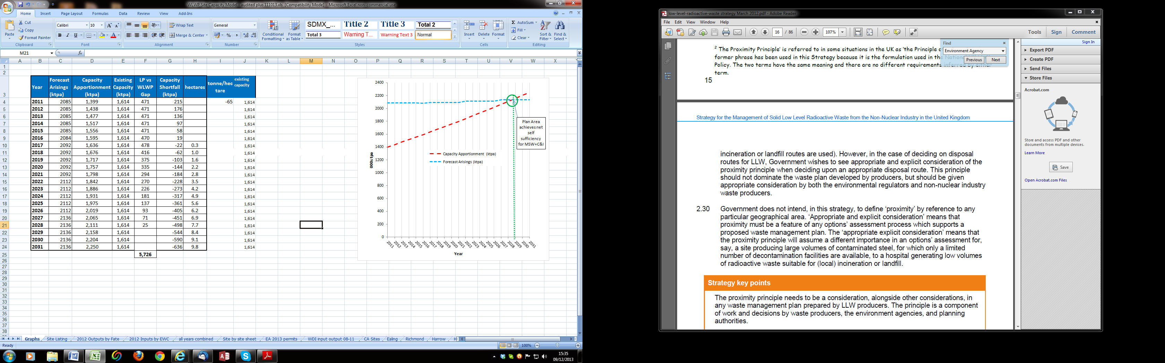

4.2 How much capacity is needed?
London Plan 2011 apportionment

4.2.1 The West London Waste Plan was prepared in accordance with the waste projections and apportionment figures contained in the London Plan (2011). The West London Boroughs are not required to meet the individual MSW and C&I waste apportionment figures in the London Plan (2011) separately as long as the total combined apportionment figure is addressed. This will require the delivery of sites and capacity as set out in the Plan.

4.2.2 Currently, West London has a range of sites where the management of MSW & C&I waste is taking place. The intention of the Plan is to prioritise the use of the existing sites in West London, including redevelopment of some waste management sites and depots, and then adding some new sites for waste management uses, as necessary.

4.2.3 Existing waste management capacity (excluding any landfill) in West London is 1.64 million tonnes per annum including both waste processing sites and the recycling undertaken at household waste and recycling centres (see Appendix 2). Subsequently, additional waste management facilities will need to be developed in West London during the Plan period up to 2031 to address the ‘gap’ between the apportionment target and the waste management capacity that currently exists (see Figure 4-2 below). Table 4-2 below sets out the existing and projected waste management capacity in West London and the additional capacity required to address the apportionment ‘gap’ for target years.

39T Figure 4-2 Projected capacity gap (in pink) between London Plan (2011) apportionment and existing capacity

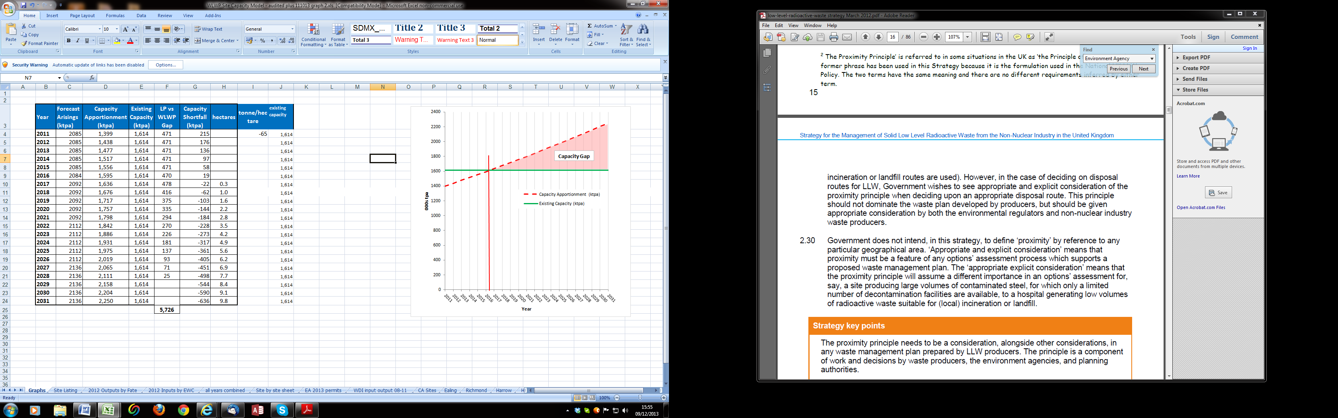

39T NB vertical red line indicates point at which apportionment exceeds existing capacity

39T4.2.4 For the six West London Boroughs to meet the London Plan (2011) apportionment targets for MSW & C&I waste, additional capacity of 162,000 tonnes by 2021, 383,000 tonnes by 2026 and 614,000 tonnes by 2031 will be needed (see Table 4-2 below). To determine what area of land will be required to provide this additional capacity, an average capacity of 65,000 tonnes per annum per hectare was used to calculate the amount,39TPP39T based on the range of possible processes and their processing intensity.

4.2.5 The London Plan (2011) does not prescribe the specific waste management technologies, their scale, or the number that will need to be implemented across London. Accordingly, the West London Waste Plan also does not take a prescriptive approach to what types of waste management facilities/technologies are required. This approach allows for innovation in the management of waste to be incorporated into proposed development in West London.

39T4.2.6 The land required to meet the apportionment capacity gap is also displayed in 39TTable 4-439T below. This shows that by 2031, West London Boroughs will need to have an additional 9.4 hectares of land available for waste management.
Table 4-4: West London Capacity Requirements for Target Years based on the London Plan (2011)
 | 2011 | 2016 | 2021 | 2026 | 2031
61TApportionment (tonnes per annum) | 1,399,000 | 1,595,000 | 1,798,000 | 2,019,000 | 2,250,000
61TTotal existing waste management capacity (tonnes per annum)61TP | 1,636,000 | 1,636,000 | 1,636,000 | 1,636,000 | 1,636,000
61TAdditional capacity required to meet the apportionment (tonnes per annum) | 0 | 0 | 162,000 | 383,000 | 614,000
61TLand required to address the capacity gap (hectares) | 0 | 0 | 2.5 | 5.9 | 9.4

4.2.7 To meet this land requirement, eight existing waste sites (accounting for 12.32 hectares) have been identified as suitable and available for redevelopment. An additional 3.20 hectares of land currently not developed for waste management use has also been identified as suitable and deliverable (see Section 5 for details of the sites).

4.2.8 Overall, it is thus estimated that within West London there are at least 15.52 hectares of land suitable and deliverable for development for additional waste related uses. This exceeds the notional land requirements of the London Plan (2011) apportionment targets and creates some flexibility in the Plan should some sites not come forward for development during the lifetime of the Plan. Annual monitoring of the Plan will help assure that provision of capacity remains sufficient for the Plan period. The table below shows how the contribution of the allocated sites to the capacity required to meet the London Plan (2011) apportionment has been calculated.

Table 4-3: Contribution of allocated sites to meeting the London Plan Apportionment

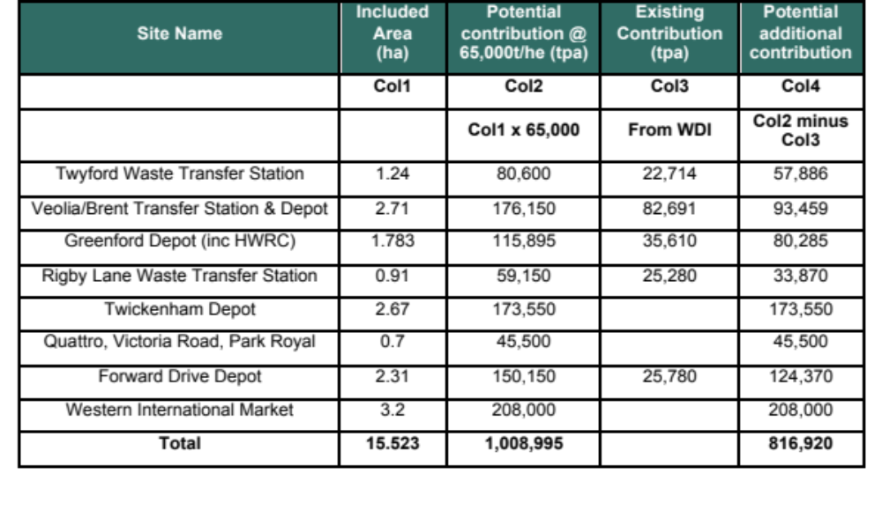

Providing for the Plan area waste before net self sufficiency is achieved

4.2.9 National Planning Policy for Waste has a stated expectation that development plan documents should make provision for all waste arising within the Plan area. In this case the London Plan (2011) apportionment trajectory only aims for self sufficiency at 2029 (Figure 4 -1 above). Before that date a shortfall of capacity between forecast arisings and existing capacity is indicated if the apportionment targets are met on a progressive basis as suggested by the London Plan. This is illustrated in Figure 4 - 3 below. The pink section shows the theoretical gap were provision to be solely driven by the London Plan trajectory. The maximum amount per annum it represents is around 470,000 tonnes reducing from 2016 when planned provision to meet the apportionment target would startSS to kick in.

Figure 4-3 Interim capacity gap between existing capacity and arisings as forecast by London Plan (2011)

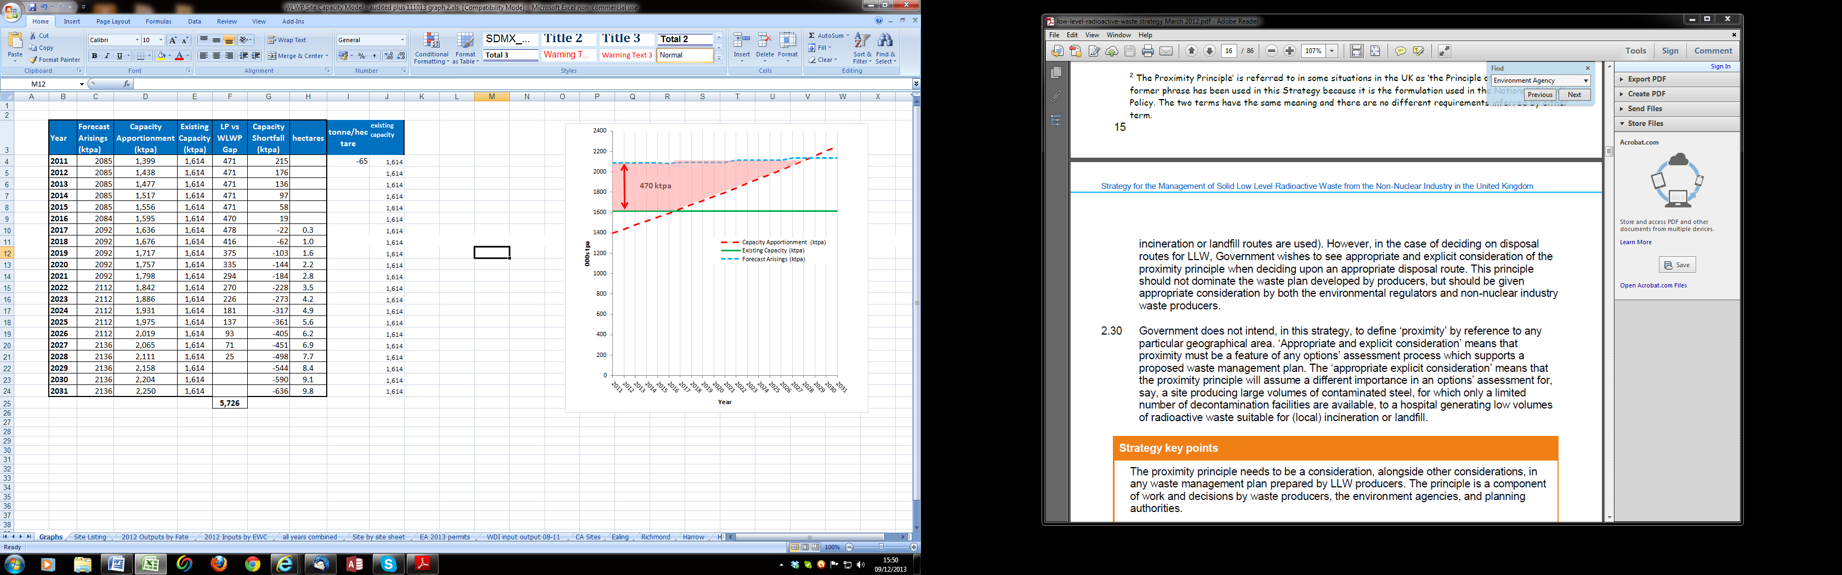

4.2.10 The following arrangements will operate in the interim. Firstly a long term contract for MSW has been entered into by the WLWA. This will involve the export of up to 300,000 tonnes per annum to an Energy from Waste facility in South Gloucestershire. In addition the WLWA has a contract to supply a minimum annual tonnage of 25,000 tonnes to Lakeside EfW plant until 2014/15 when the tonnage increases to 45,000 tonnes. The following year (2015/16) the tonnage increases to 90,000 tonnes and remains at that level until the final year of the contract in 2034/5. While this export of material to generate energy is not countable towards the apportionment targets under the terms of the London Plan (2011) it will account for the bulk of the shortfall. In addition around 70,000 tonnes of waste (as refuse derived fuel) may be sent to the Slough Heat & Power facility or exported abroad for energy recovery. So in total 460,000 tonnes per annum are accounted for to address the apparent shortfall. It should be emphasised that these arrangements reflect actual arrangements put in place and are not a strategy developed as part of the Plan-making process. However the fact that such long term arrangements catering for significant quantities of West London's waste exist, cannot be ignored.

4.3 What kind of facilities will be needed?

4.3.1 A range of different waste management facilities may be required to provide for management of waste within West London, including recycling, composting and energy recovery. Modern waste management facilities utilise clean technologies and are subject to stringent regulation and monitoring of their operations and impacts. Innovative design and architecture are important to ensure facilities are acceptable and sensitive to their settings, although many technologies can be housed in industrial building similar in appearance to a warehouse. Appendix 4 to this report gives a brief description of most of the principal waste treatment technologies.

4.3.2 It is important that modern methods of dealing with waste are found which alsoS Sproduce value added, usable outputs (including fuel, heat and power). Waste management facilities should be seen positively, as an opportunity rather than a ‘bad neighbour’, as they can be co- located with developments and industry to provide heat, power and other beneficial products potentially attractive to industrial, commercial and residential developments.

4.3.3 The West London Waste Plan identifies sites for general waste management use and sets out policies to ensure development is suitable for the site and its surrounding land uses. The Plan is designed to be flexible to allow for developments and improvements in waste management technologies and the changing habits of consumers and waste producers. Any planning application for additional waste management capacity will be considered against the West London Waste Plan policies, including those of the London Plan, and other relevant policies and material considerations and be subject to public consultation.

4.4 Construction, Demolition and Excavation Wastes

4.4.1 Construction, Demolition and Excavation (CD & E) waste is a large waste stream within London, although it is not included within the London Plan (2011) apportionment target assigned to boroughs. Work undertaken in support of the Plan has established that the Plan Area has a substantial quantity of processing capacity for this waste stream and that the London Plan (2011) city-wide targets of 95% recycling and reuse by 2020 are close to being met. This is expected to continue into the future and accordingly no allocations are made in this plan for facilities dealing specifically with such wastes. However the evidence also indicates that it is not possible for the more specific target of 80% of that recycling to be met in the form of aggregates by 2020 due to the lack of suitable waste. The preference in West London is to ensure more on-site recycling and re-use on construction sites together with effective use of existing waste management sites and the appropriate provision of facilities at mineral extraction sites to ensure adequate provision of treatment capacity for this waste stream.S SParticular policy encouragement will be given to development of capacity for the production of material suitable for use as substitutes for virgin materials such as recycled aggregates.

4.5 Hazardous Wastes

4.5.1 Policy 5.19 of the London Plan (2011) states that the Mayor will prepare a Hazardous Waste Strategy for London and will work in partnership with the Boroughs, the Environment Agency, industry and neighbouring authorities to identify the capacity gap for dealing with hazardous waste and to provide and maintain direction on the need for hazardous waste management capacity. This policy also directs that existing hazardous waste sites should be safeguarded unless compensatory provision is made. In January 2014 the Mayor released a reportPP to help inform London’s hazardous waste management capacity requirements and planning policy for the next iteration of the London Plan (FALP) adopted in 2015. This study is a non-statutory document and sets out the Mayor's understanding of London’s hazardous waste management arrangements.

4.5.2 Work undertaken in support of the PlanPP has established that the Plan area has a moderate level of capacity for this waste stream with a number of sites managing hazardous waste within the Plan area. Other flows have been tracked with the general finding being that waste of this type travels within 1.5 hours of the Plan area for treatment. The resilience of these flows have been confirmed by contacting the appropriate receiving authorities. It is not anticipated that a substantial local need for new capacity will arise and so land allocations specifically for the development of additional hazardous waste management capacity have not been identified in this Plan. However Policy WLWP 1 is included to encourage the development of further capacity where it is identified as being needed in the regional context. Planning applications for new hazardous waste facilities will be determined in the same way as applications for all waste management facilities and the capacity of hazardous waste facilities will be monitored closely to establish whether additional provision is required at a later date.

5 The Sites

5.1.1 In accordance with the criteria outlined in National Planning Policy for Waste, the West London Waste Plan identifies 8 sites which it considers will ensure adequate waste management provision for the lifetime of the Plan. The sites have been subjected to a detailed evaluation and assessment which is summarised in an accompanying report on the site selection processPP. A description of the sites proposed for allocation is included in Appendix 6.

5.1.2 The Plan identifies 15.52 hectares considered to be suitable and available on existing and new sites for future waste management located as per Figure 5-1 below. Table 5-1 sets out existing sites capable of redevelopment to expand existing capacity, while Table 5-2 refers to additional sites that may be developed for waste management purposes. Maps showing the location of the sites and their boundaries are also provided.

5.1.3 In order to retain flexibility and avoid stifling innovation, the Plan does not dictate which type of waste management technology could be developed in which location. Any proposal for development at any of the allocated sites will be considered against its consistency with all the polices of this Plan, as well as other policies included in the wider Development Plan for that area at that time. This means that it is possible that detailed assessment may reveal that certain proposals may not prove to be acceptable in certain locations as their predicted impacts on the surroundings cannot be adequately mitigated, However all the allocated sites have been assessed as broadly suitable for the development of additional waste management capacity that would count towards meeting the London Plan apportionment.

Figure 5-1: Location Plan showing all allocated sites (Policies Map)

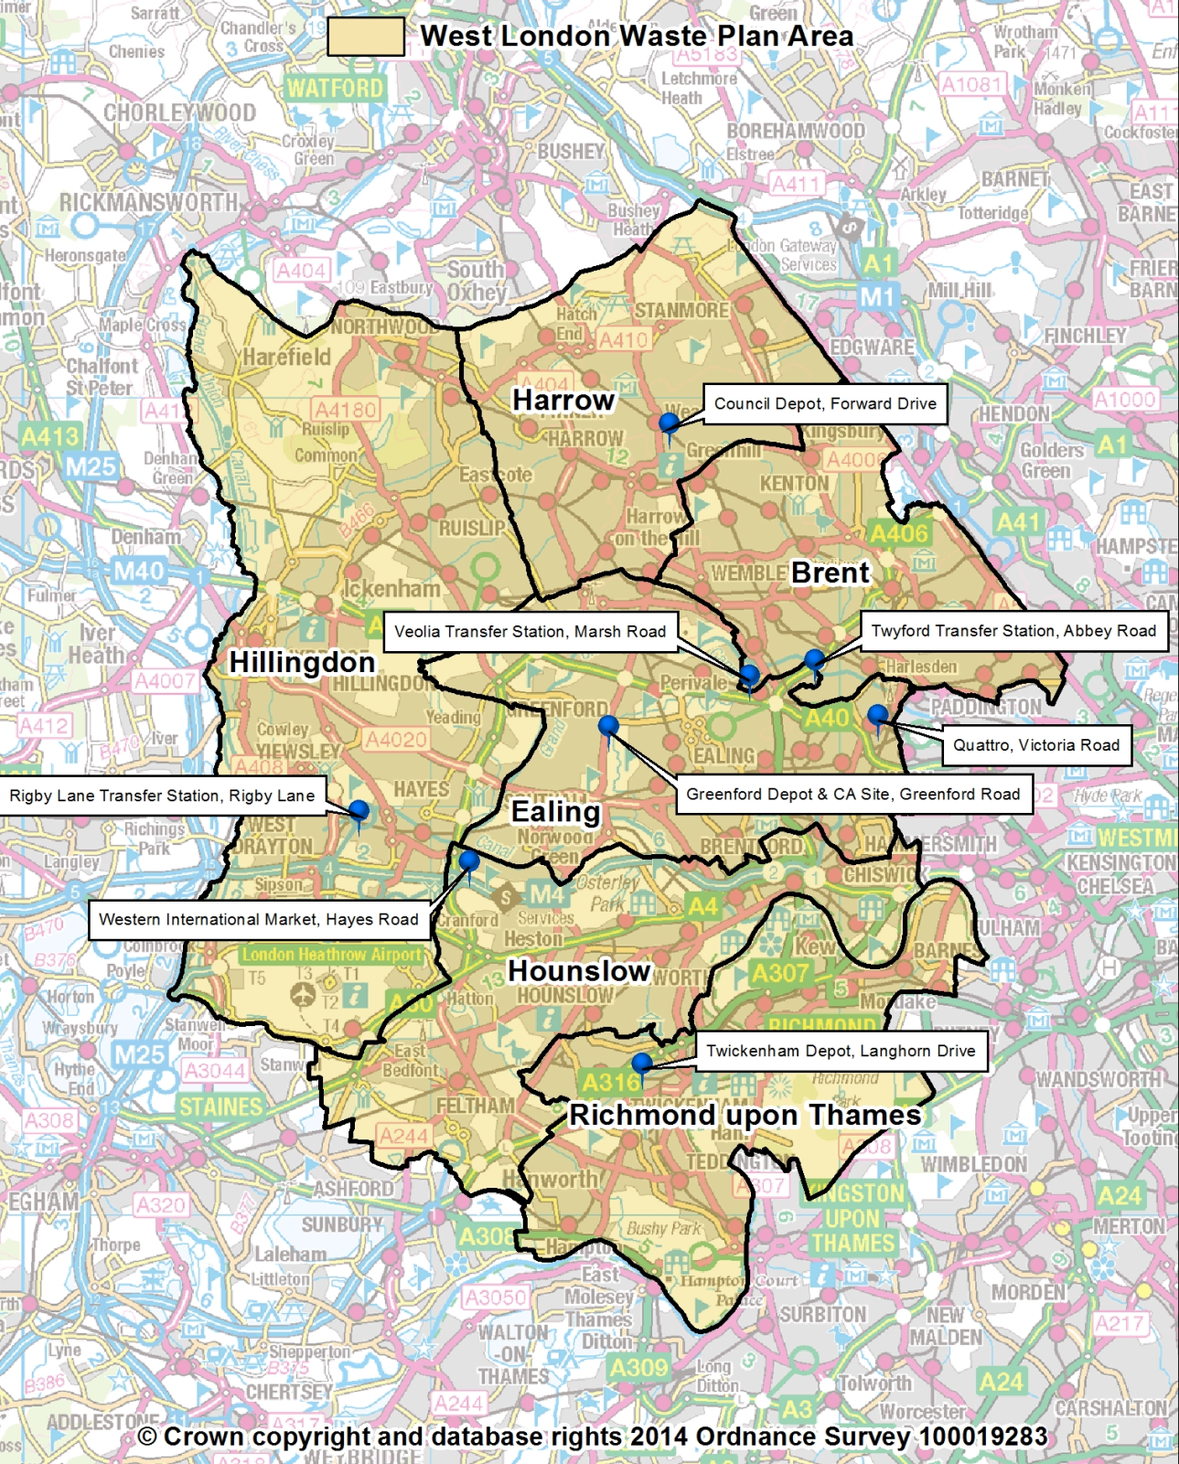

Table 5-5: Existing waste sites considered to have potential for redevelopmentP
Site Number | Description | Site Type | Site Area (ha) | Borough
352 | Twyford Waste Transfer Station | Transfer Station | 1.24 | Brent
1261 | Veolia Transfer Station, Marsh Road | Transfer Station | 2.71 | Brent
309* | Greenford Reuse & Recycling Site | Transfer Station | 1.78 | Ealing
310* | Greenford Depot, Greenford Road | Depot Facility | 1.78 | Ealing
328# | Quattro, Victoria Road, Park Royal | Transfer Station | 0.7 | Ealing
222 | Council Depot, Forward Drive | Depot Facility | 2.31 | Harrow
331 | Rigby Lane Waste Transfer Station | Transfer Station | 0.91 | Hillingdon
342 | Twickenham Depot | Depot Facility | 2.67 | Richmond
Total |  |  | 12.32
*These two sites are contiguous and part of a larger site: for the purposes of the Plan, they are considered a single consolidated site
# This site is subject to an HS2 Safeguarding Direction and will not be available from 2017 until 2024
High Speed 2 (HS2)
5.1.4 It should be noted that one of the sites proposed for allocation - Quattro at Victoria Road - has been identified by HS2 Ltd as requiring safeguarding under the HS2 Safeguarding Direction. This means that if HS2 proceeds it will only become available from 2024 for waste management uses, following its use to host a construction compound. The site has been included to provide a contingency capacity for the latter period of the Plan although it is not essential to meeting the apportionment targets of the London Plan (2011).

Site 352 Twyford Waste Transfer Station, Abbey Road, Brent

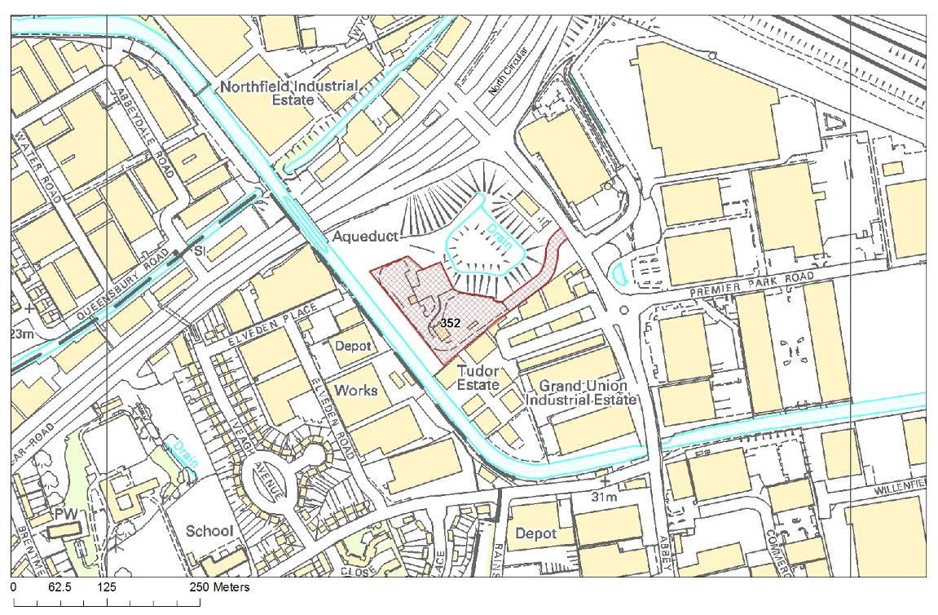
© Crown copyright and database rights 2013 Ordnance Survey 100019283
Site 1261 Veolia Transfer Station, Marsh Road, Alperton, Brent

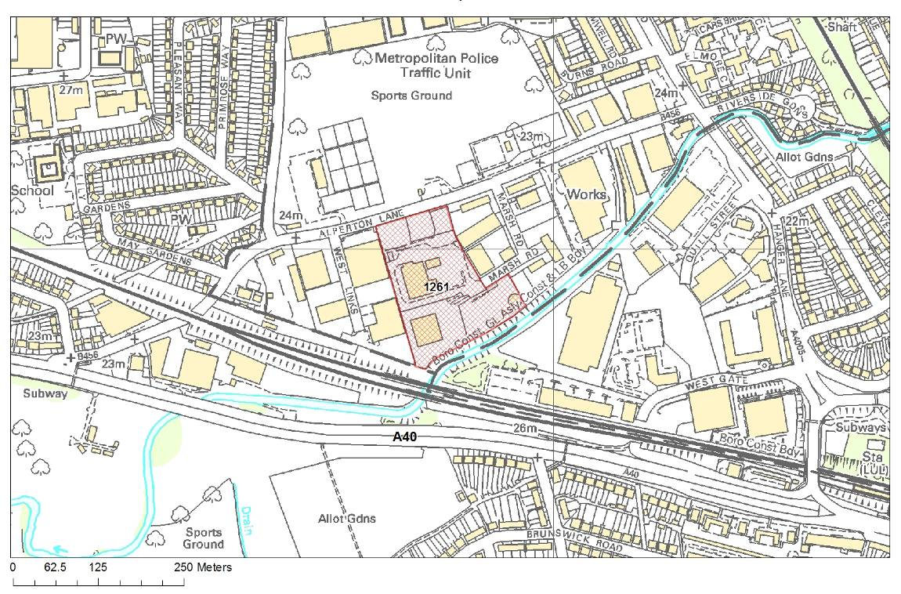
© Crown copyright and database rights 2013 Ordnance Survey 100019283
Site 309 Greenford Reuse & Recycling Site & Site 310 Greenford Depot, Greenford Road, Greenford, Ealing
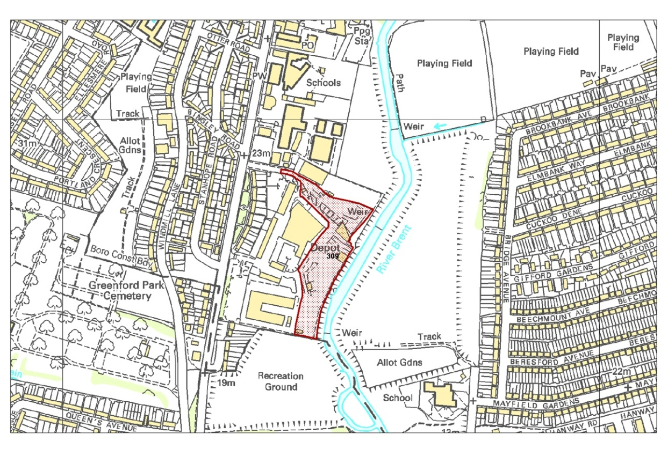
© Crown copyright and database rights 2013 Ordnance Survey 100019283
Site 328 Quattro, Victoria Road, Park Royal, Ealing
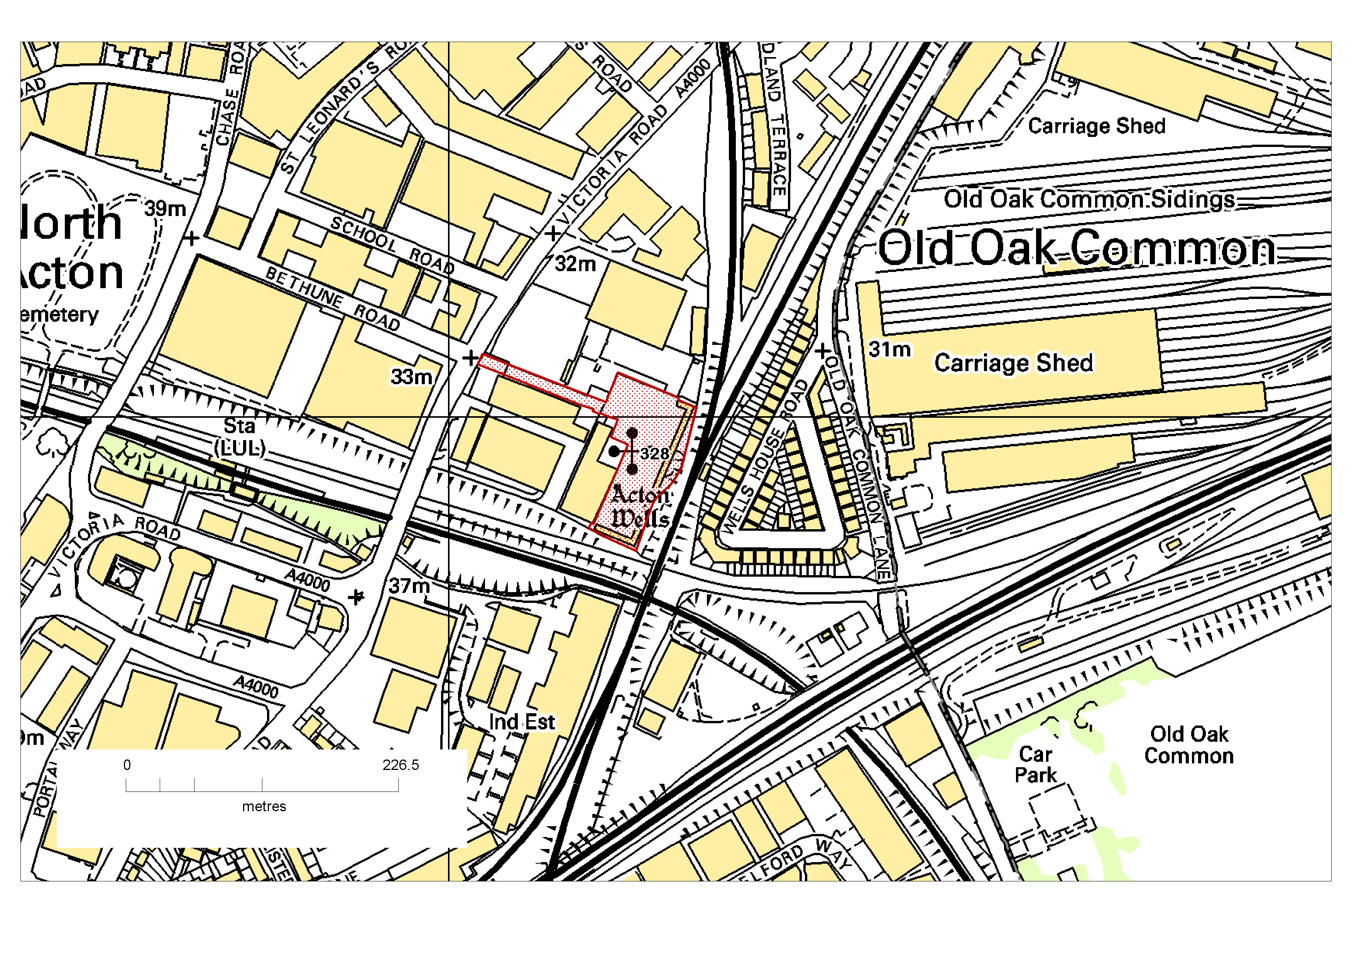
© Crown copyright and database rights 2013 Ordnance Survey 100019283

Site 331 Rigby Lane Waste Transfer Station, Hayes, Hillingdon

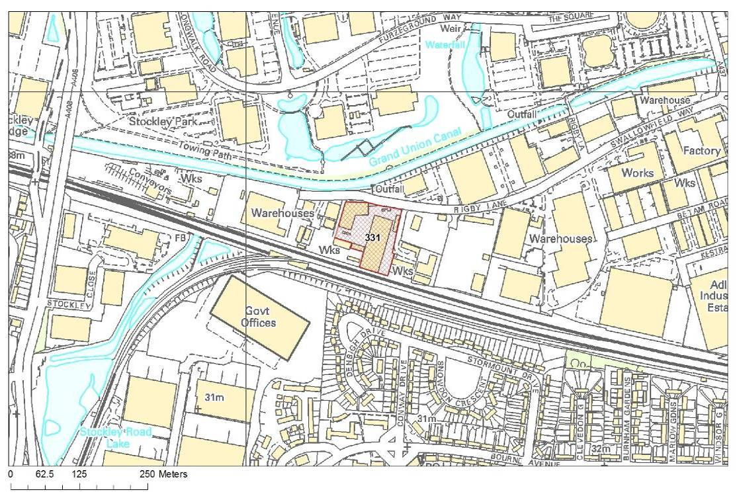
©Crown copyright and database rights 2013 Ordnance Survey 100019283

Site 342 Twickenham Depot, Langhorn Drive, Twickenham, Richmond

Site 222 Council Depot, Forward Drive, Harrow
© Crown copyright and database rights 2013 Ordnance Survey 100019283
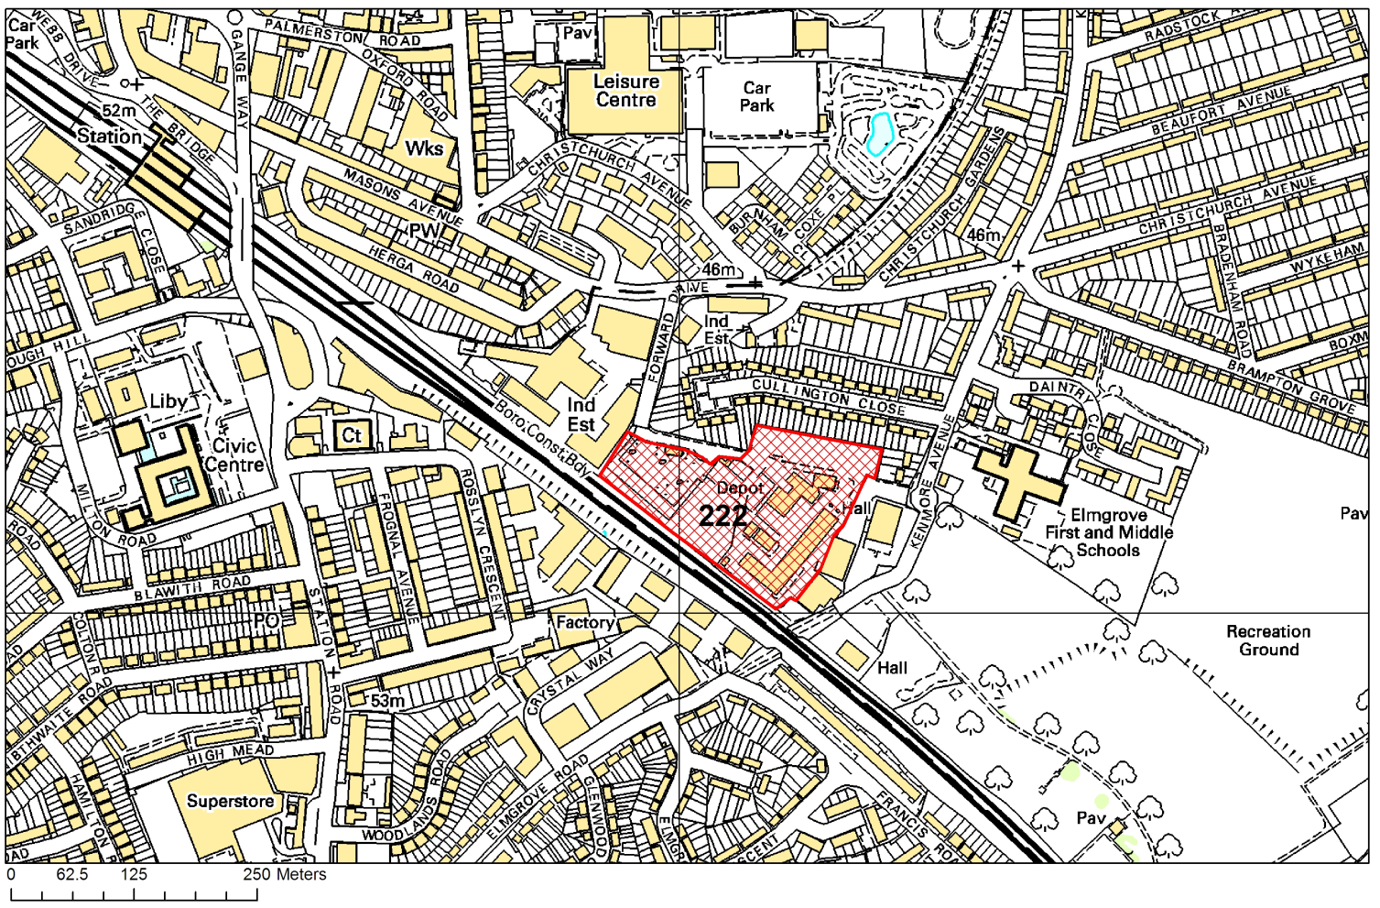

Table 5-2: Additional sites with opportunity for developing waste facilities
Site Number | Site Name | Site Area (ha) | Borough
2861 | Western International Market | 3.20 | Hounslow
Total |  | 3.20

Site 2861 Western International Market, Hayes Road, Southall, Hounslow

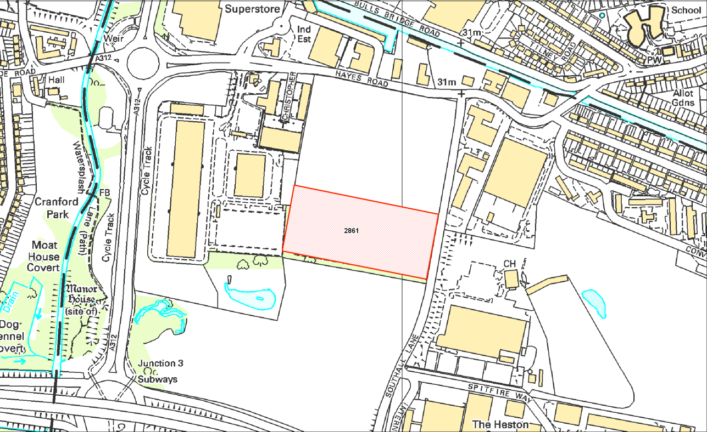
@Crown copyright and database rights 2013 Ordnance Survey 100019283

6 West London Waste Plan Policies

6.1 Policy WLWP 1 – Provision of New Waste Management Capacity
6.1.1 The following policy is aimed at delivering the necessary minimum amount of additional waste management capacity of the right type and at the right time. Developments are to accord with all parts of the development plan unless material considerations indicate otherwise. Particular attention will be given to avoiding unacceptable harm to the environment and adverse effects on the well-being of communities.

6.1.2 In respect of Municipal Solid Waste, and Commercial and Industrial Waste, the main requirement arising out of the London Plan (2011) is to meet the stated apportionment for the six West London Boroughs combined. This is the principal aim of the policy. However, the current London Plan (2011) projections indicate that net self-sufficiency would not be achieved until 2029 for London as a whole. In the interim, there would be a gap between the quantity of eligible existing capacity within West London (the apportionment baseline of 1.64 million tpa) and the quantity of MSW and C&I waste forecast to arise in West London. In these circumstances, the provision of capacity to manage the requisite London Plan tonnages at a faster rate than indicated will be encouraged. The expectation is that substantive provision would be made on allocated sites (Policy WLWP 2) in the first instance. Any such provision should be consistent with the waste hierarchy.
Policy WLWP 1 - Provision of New Waste Management Capacity

Apportioned Waste – MSW & Commercial and Industrial Waste:

Over the period to 2031, there is a need for about 614,000 tonnes of additional annual capacity to meet the apportionment set in the London Plan (2011). This is to be delivered on the allocated sites identified in Policy WLWP 2 as follows:

- 162,000 tonnes in the period up to 2021
- A further 221,000 tonnes (total 383,000 tonnes) in the period 2021 to 2026
- A further 231,000 tonnes (total 614,000 tonnes) in the period 2026 to 2031

The requirement is for capacity in the re-use, recycling, and other recovery categories.

Provision over and above the tonnages required to meet the London Plan (2011) apportionment and of a nature similar to that identified above will be encouraged where this would contribute towards net self-sufficiency.

Provision should be made in accordance with the waste hierarchy, ^{27a} and this should be addressed and justified as a pre-requisite of any grant of planning permission.
Non apportioned Waste:

Development of management capacity will be supported in principle that contributes towards net self sufficiency across the Plan Area for:

a. Construction, Demolition and Excavation Waste in accordance with the waste hierarchy with particular support for the production of material suitable for use as substitutes for virgin materials such as recycled aggregates; and

b. Hazardous waste treatment capacity that accords with any hazardous waste strategy, or similar, prepared by the Mayor of London.

6.2 Policy WLWPS S2 Safeguarding and Protection of Existing and Allocated Waste Sites

6.2.1 A list of all the sites that are in existing waste management use in the West London Boroughs can be found in Appendix 2. These safeguarded sites form an essential resource for dealing with all waste streams within the Plan area and protection of these sites minimises the need for any additional sites and so they are all safeguarded. This also ensures general conformity with Policy 5.17 G (a) and paragraph 5.82 of the London Plan (2011). Policy WLWP 3 provides support for waste development proposals on existing sites.

6.2.2 The sites in Table 5.1 are those existing sites that are considered to have particular potential for redevelopment for future waste capacity expansion, including alternative forms of waste management that could result in waste moving up the hierarchy. Table 5.2 contains the additional site that is allocated in the Plan for future waste management facilities. The protection of these sites is required to ensure the West London Boroughs' pooled apportionment targets are met and thereby demonstrate general conformity with the requirement of the London Plan (2011).

6.2.3 The policies of this Plan apply to the existing management capacity for hazardous waste and to proposal’s for additional such capacity.
Policy WLWP 2 – Safeguarding and Protection of Existing and Allocated Waste Sites
Land accommodating existing waste management uses in West London will be protected for continued use for waste management P^{27b}P.
Existing sites which have been allocated as having the potential for capacity expansion by redevelopment (Table 5-1) and new sites with potential for development for waste management facilities (Table 5-2) will also be safeguarded.
To ensure no loss in existing capacity, re-development of any existing waste management sites must ensure that the quantity of waste to be managed is equal to or greater than the quantity of waste which the site is currently permittedP to manage, or that the management of the waste is being moved up the waste hierarchy.
Development for non-waste uses will only be considered on land in existing33TP27cP33T waste management use, or land allocated in Table 5-2 if compensatory and equal provision of capacity for waste, in scale and quality, is made elsewhere within the West London Boroughs.

6.3 Policy WLWP 3 – Location of Waste Development

6.3.1 To ensure conformity with the London Plan (2011), the Plan identifies 15.52 ha of land for the development of waste management facilities to meet the pooled apportionment for the six West London Boroughs up to 2031.

6.3.2 All existing waste management sites in the six Boroughs, allocated existing sites with potential for redevelopment, and new allocated sites are safeguarded for waste management uses under this Plan, unless an equal and compensatory suitable, acceptable and deliverable site can be provided, or there is an appropriate level of movement up the waste hierarchy.

6.3.3 The Plan identifies the safeguarded existing sites and proposed sites considered appropriate and suitable for waste management development as set out in Table 5-1 and Table 5.2. Policy WLWP 3 sets out the key criteria against which planning applications for waste management capacity will be determined.

6.3.4 Policy WLWP 3 also sets out the circumstances under which development proposed on unallocated or new sites may also come forward.

6.3.5 Assessments of ongoing requirements for capacity to meet the London Plan apportionment will take account of the most recent monitoring of the implementation of the Plan.
Policy WLWP 3 – Location of Waste Development
Waste development proposals on existing waste management sites33TP28AP33T and the sites listed in Table 5-2 will generally be supported, provided that the proposals comply with the Development Plan for the area.S
Waste development on other sites will be supported in principle if the proposals comply with the other WLWP policies and the Boroughs’ adopted development plans, and:
- It can be demonstrated that the development cannot be delivered at any available and suitable existing waste management siteSS within the Borough P where the development is proposed and at the sites listed in Tables 5-1 and 5-2; and
- In the case of facilities proposed for the management of MSW and C&I waste, identified sites in Tables 5-1 and 5-2 have not come forward and it can be demonstrated that there will be a shortfall in the waste management capacity required to meet the Boroughs’ joint apportionment target as specified in Policy WLWP 1; and
- There is no adverse cumulative effect, when taken together with existing waste management facilities, on the well-being of the local community, including any significant adverse impacts against the WLWP sustainability objectives (see Appendix 1); and
- The proposed site meets the criteria set out in the subsequent WLWP Policies if applicable.

6.4 Policy WLWP 4 – Ensuring High Quality Development

6.4.1 Modern waste management facilities should bring a benefit to the community and environment. Policy WLWP 4 provides a range of criteria to ensure developers consider and mitigate the impacts of their development on the environment, the community and the appearance of the local area. Developments should also comply with the London Plan, any borough Local Plans, Development Management Policy documents, Site Allocations and Area Action Plans.

6.4.2 As a general principle, all waste management developments will be expected to complement the surrounding area and act as a good neighbour to all existing and proposed usesPP on neighbouring land and in the vicinity.

6.4.3 Noise, litter and all other emissions (including those to air and water) must be adequately controlled so as not to cause any adverse impact on the surrounding area. Developers will be expected to submit details of proposed control measures with any planning application. Where proposals involve operations which could result in fugitive emissions (e.g. noise, dust, litter etc.) there is an expectation that such operations will be properly contained and normally this will be achieved by enclosing operations within a covered building enclosed with vertical sides with defined access and egress points33TP29AP33T.

6.4.4 Developers will be expected to have actively considered innovative and sustainable design approaches to ensure that the development is in accordance with best practice and complements the local area in terms of topography, landscape and setting. Where necessary a Design and Access statement should be submitted to set out matters which include how the facility complements the local area and ensure that there is no significant effect on existing transport facilities, Public Rights of Way, or public safety.

6.4.5 Where sites include, or are likely to have an impact on the setting of a heritage asset, including archaeology, it should be demonstrated that the development will conserve the asset. Where the site has potential to include assets with archaeological interest, such as if it is in an archaeological area identified in a local plan or may affect a site recorded on the Greater London Historic Environment Record, an appropriate desk based assessment and where necessary, a field evaluation, will be required to accompany the planning application. Where such assessment and evaluation confirms a significant archaeological interest then appropriate mitigation by design or investigation will also be required.

6.4.6 The road network within West London is often congested and therefore proposals must demonstrate active consideration of transport modes other than by road. There must not be any significant or unacceptable adverse impacts on the local road network or other road users, in terms of congestion or parking associated with the development. Proposals should demonstrate that adequate parking for all vehicles is available on site.

6.4.7 If the proposed waste management development is required to have an Environmental Impact Assessment, then a Health Impact Assessment is also required.

6.4.8 The management of waste in accordance with the waste hierarchy is a key element of European, national and regional policy. The West London Boroughs support the increased management of wastes as far up the hierarchy as possible and each of the six Boroughs has a commitment to waste minimisation and recycling/reuse. Waste minimisation is also an important issue to the residents and community within West London.

6.4.9 The West London Boroughs support the use of local, reclaimed, renewable, recycled and low environmental impact materials in construction and estate management. Their details should be considered and included within the sustainable design and construction statement. Materials should be sourced from within 100km from the site, where available and appropriate.

6.4.10 Development should not exacerbate flood risk and should take place in accordance with the Environment Agency’s policies on the protection of groundwater.
Policy WLWP 4 – Ensuring High Quality Development
All waste development proposals will be required to demonstrate, for both the construction and operational phases of the development, that:
- Development will be permitted only where it can be shown that unacceptable impact to local amenity will not arise from the construction andS Soperation of a facility;
- Adequate means of controlling noise, vibration, dust, litter, vermin, odours, air and water-borne contaminants and other emissions are incorporated into the schemeP

- The development is of a scale, form and character appropriate to its location and incorporates a high quality of design, to be demonstrated

- through the submission of a Design and Access statementPP as appropriate;
- Active consideration has been given to the transportation of waste by modes other than road, principally by water and rail and this has been incorporated into the scheme or proven not to be practicable;
- Transport directly and indirectly associated with the development will not exceed the capacity of the local road network or result in any significant adverse impact on the amenities of the area. Where necessary, this is to be demonstrated by a Transport Assessment33TP31AP33T;
- An appropriate BREEAMPP or CEEQUALPP rating, as specified in borough Development Plans, will be achieved;
- The development has no significant adverse effects on local biodiversity and it can be demonstrated that there will be no significant adverse impacts or effects on the integrity of an area designated under the “Habitats Directive”;
- There would not be a significant impact on the quality of surface and groundwater. The development incorporates the principles of Sustainable Drainage Systems (SUDS) unless evidence is provided to justify alternative drainage methods;
- There will be no increased flood risk, either to the immediate area or indirectly elsewhere. Where necessary33TP33AP33T, this is to be demonstrated by a Flood Risk Assessment;
- Green Travel Plans have been considered, where appropriate33TP33BP33T.
- The site does not contain features, or will not lead to substantial harm to, or loss of significance of, any heritage assets such as conservation areas, archaeological sites, listed buildings etc;
- There is no foreseeable adverse impact on health, and where necessary this is to be demonstrated by a Health Impact Assessment.
In addition:
- Adjacent development proposals which would prevent or prejudice the use of safeguarded sites for waste purposes will be resisted unless suitable alternative provision is made.
- Applications shall provide details of the management arrangements for residues arising from any waste management facility.

6.5 Policy WLWP 5 – Decentralised Energy

6.5.1 New waste management and recycling methods can offer more efficient use of resources than existing waste management methods. Waste management facilities can also contribute to the provision of decentralised energy by providing heat and power for use in domestic and industrial processes.

6.5.2 The London Plan and emerging national planning policy guidance encourages boroughs to take opportunities for the development of combined heat and power technologies.
Policy WLWP 5 – Decentralised Energy
All waste management facilities that are capable of directly producing energy or a fuel must secure, where reasonably practicable:
The local use of any excess heat in either an existing heat network or through the creation of a new network;
The use of biogas/syngas in Combined Heat and Power facilities, either directly through piped supply or indirectly through pressurisation and transport;
The use of any solid recovered fuel in Combined Heat and Power facilities or as a direct replacement for fossil fuels in London; or
Any other contribution to decentralised energy in London.
Where it is demonstrated that the provision of decentralised energy is not economically feasible or technically practicable, the development shall not preclude the future implementation of such systems.
Energy from waste facilities will only be considered where it can be demonstrated that they qualify as a recovery operation as defined in the Waste Framework Directive. Proposals for Energy from Waste should demonstrate that they will not compromise the management of waste in accordance with the waste hierarchy requirement of the Waste Framework Directive.

6.6 Policy WLWP 6 – Sustainable Site Waste Management

6.6.1 The management of waste in accordance with the waste hierarchy is a key element of European, national and regional policy. The West London Boroughs support the increased management of wastes as far up the hierarchy as possible and each of the six Boroughs has a commitment to waste minimisation and recycling/reuse. Waste minimisation is also an important issue to the residents and community within West London.

6.6.2 The West London Boroughs support the use of local, reclaimed, renewable, recycled and low environmental impact materials in construction and estate management. Their details should be considered and included within the sustainable design and construction statement and the Site Waste Management Plans. Materials should be sourced from within 100km from the site, where available and appropriate.

6.6.3 Site Waste Management Plans are intended to do the following:
- Describe each type of waste expected to be produced
- Estimate the quantity of each type of waste
- Identify the waste management action for each type of waste including re-using, recycling, recovery or disposal.
Once the development has commenced the developer should ensure the following takes place with respect to the plan:
- Review and update the plan
- Record quantities and types of waste produced
- Record the types and quantities of waste that have been:
  - Reused (on or off site)
  - Recycled (on or off site)
  - Sent of other forms of recovery (on or off site)
  - Sent to landfill
  - Otherwise disposed of

The Site Waste Management Plan should be updated to reflect the progress of the project.

Policy WLWP 6 – Sustainable Site Waste Management
To encourage sustainable waste management, waste management developments will be permitted where it can be demonstrated that:
- At least 10% of the materials or products used in the construction and operation of the development are re-used or recycled and sourced from within 100km from the site;
- Construction, demolition and excavation wastes are minimised and then reused or recycled on site, where practicable and environmentally acceptable; and
- Site Waste Management Plans are comprehensive and capable of being delivered.
- Where on-site management of waste is not possible, active consideration has been given to the transportation of construction, demolition and excavation wastes away from the site by modes other than road, principally by water and rail and this has been incorporated into the scheme or proven not to be practicable.

6.7 Policy WLWP 7 – National Planning Policy Framework: Presumption in Favour of Sustainable Development

6.7.1 The National Planning Policy Framework 2012 introduced the presumption in favour of sustainable development which applies to waste development.

Policy WLWP 7 – National Planning Policy Framework: Presumption in Favour of Sustainable Development

When considering development proposals, boroughs will take a positive approach that reflects the presumption in favour of sustainable development contained in the National Planning Policy Framework. They will always work proactively with applicants jointly to find solutions which mean that proposals can be approved wherever possible, and to secure development that improves the economic, social and environmental conditions in the area.

Planning applications that accord with the policies in this waste plan (and, where relevant, with policies in neighbourhood plans) will be approved without delay, unless material considerations indicate otherwise.

Where there are no policies relevant to the application or relevant policies are out of date at the time of making the decision then the borough will grant permission unless material considerations indicate otherwise – taking into account whether:

- Any adverse impacts of granting permission would significantly and demonstrably outweigh the benefits, when assessed against the policies in the NPPF taken as a whole; or

- Specific policies in the NPPF indicate that development should be restricted.

7 Monitoring of the West London Waste Plan
7.1 Monitoring Mechanisms and Proposed Indicators

7.1.1 Once the West London Waste Plan is adopted, the implementation and effectiveness of its policies will be reported each year in each of the Boroughs’ Authority Monitoring Reports. Monitoring will involve the collation of data to check progress against the Plan’s objectives and implementation of the Plan’s policies. For example, this mechanism will enable the West London Boroughs to compare quantities of waste actually produced with those forecast and to monitor development on the sites identified in the Plan. The Boroughs will then consider whether the allocation of sites is sufficient and whether the Plan needs reviewing and updating.

7.1.2 The proposed indicators to be used to report progress for each borough and the six combined West London Boroughs include:
- Quantity of each type of waste produced;
- Capacity (maximum permitted throughput in tonnes per annum) of new waste management facilities given planning permission in the previous year:
- separately for MSW, C&I and CD&E
- recycling and composting
- other recovery
- landfill;
- Additional waste management capacity (maximum permitted throughput in tonnes per annum) on:
- sites allocated within the West London Waste Plan, and
- non-allocated sites;
  - Loss of waste management capacity on:
- sites identified as contributing to the London Plan (2011) apportionment
- other sites;
- The quantity (maximum permitted throughput in tonnes per annum) of consented capacity that is actually active in any given year - active being accepting waste;
- The quantity (maximum permitted throughput in tonnes per annum) of consented capacity that is under construction in any given year;
- The quantity of municipal waste (tonnes) managed in the following ways:
- Re-use;
- recycling;
- Composting
- other recovery;
- landfilled (showing whether management took place within or beyond the Plan area (where known);
- Comparison of municipal and commercial & industrial waste that is recovered compared with the apportionment targets set out in the London Plan (2011). This should show whether management took place within or beyond the Plan area (where known);
- Tonnage of construction, demolition and excavation waste managed, showing management method and whether management took place within or beyond the Plan area (where known);
- The quantity of recycled aggregates produced and other waste which could be used in place of primary materials following processing (in the Plan area);
- Tonnage of hazardous waste produced and managed, showing if management took place within or beyond the Plan Area;
- Amount of energy produced and delivered using waste as a fuel source; and
- Other indicators that may be decided to measure performance against policies and/or the Sustainability Indicators set out in the Sustainability Appraisal.
- the number of sites consented that offer non-road transport options, the number of those sites where such options have been implemented and the total tonnage transported through non-road options where known.

7.1.3 Where monitoring identifies that there is a major failure to meet the targets for waste management within the Plan area the six West London Boroughs will seek to identify the reasons why this is occurring and take effective management measures to rectify any problems that may put delivery of the Plan’s strategy at risk. The triggers for such an investigation are included in table 7-1.

7.1.4 Table 7-1 indicates how the policies of the Plan will be monitored.
Table 7-6 – Monitoring programme for the West London Waste Plan
WLWP Policy & Strategic Objective | Indicator | Reason | Delivery | Delivery Agency | Trigger for review of Plan/policy
Policy WLWP 2 & 3  Objectives 1, 2, 5 | Number and capacity of safeguarded sites and amount of any compensatory land provided | To ensure no loss of waste capacity in the West London area | The planning process | Local Authorities  Waste industry  Developers | The waste management capacity provided by existing and allocated sites falls to a level 10% below or rises to a level 10% above that required by the London Plan apportionment.
Policy WLWP 4  Objectives 1, 3, 4, 5 | Number, type and capacity of waste facilities approved and completed at safeguarded sites and new identified sites  Impact of new sites measured using:  1. Number of sites failing to comply with any relevant environmental permit  2. Number of enforcement complaints breaches of conditions  3. Negative impact/damage to heritage asset or setting | Compliance with sequential policy approach  To ensure adequate waste capacity is being provided  To ensure sites are not causing harm to the environment or communities including heritage assets | The planning process and combined private and public initiative to provide waste management developments | West London Waste Authority  Waste industry | 1. 10% of existing sites are failing to comply with any relevant environmental permit.  2. Substantiated complaints regarding permitted waste sites exceed one per borough in any six month period.  3. Breaches of conditions exceed one per borough in any six month period.  4. One existing waste site causes a negative impact or damage to a heritage asset or setting (confirmed by English Heritage).
Policy WLWP 5  Objectives 1, 3, 5 | Amount of energy produced and delivered | To ensure compliance with the aims of the London Plan (2011) and prescribed carbon savings | Through the planning and permitting process. | Local Authorities  Waste industry  Developers | One existing permitted thermal treatment facility operating without harnessing energy
Policy WLWP 6  Objectives 1, 2, 5 | Amount of construction waste sent to landfill | To monitor progress towards Plan strategy of zero waste to landfill. | Use of Site Waste Management Plans; monitoring and enforcement of these and planning conditions | Developers  West London Boroughs | Amount of construction waste sent to landfill (for non-engineering purposes) exceeds London Plan landfill diversion targets
Policy WLWP 7  Objectives 1, 5 | The success of the implementation of Policy WLWP 7 will be dependent on the success of implementation of all other policies | To ensure compliance with the NPPF | Through the planning process | Developers  West London Boroughs | N/A

7.2 The Boroughs will carry out appropriate inspections of waste facilities when investigating
compliance with planning conditions and possible breaches of planning control.
7.3 Review of the West London Waste Plan
7.3.1 The Plan will be reviewed following adoption of the Further Alterations to the London Plan (FALP) and any other changes to the policies of the London Plan and at least every five years. In part this is to ensure that the Plan is still meeting the apportionment requirements of the London Plan (2011) and to take into account any changes to waste management capacity and the need for the identified sites.

8 Glossary
Term/Acronym | Definition
Anaerobic Digestion (AD) | A process whereby biodegradable material is broken down in the absence of air (oxygen). Material is placed into a closed vessel and in controlled conditions it breaks down into digested material and biogas.
Apportionment | Please see ‘London Plan (2011) Apportionment’.
Area Action Plan | Type of Local Development Document focused on a specific location or area which guides development and improvements. It forms one component of a Local Plan.
Autoclave | A method of sterilisation. Waste is loaded into a rotating sealed cylinder and the biodegradable fraction of this waste is then broken down by steam treatment into a homogeneous ‘fibre’.
Biodegradable | Biodegradable materials are generally organic, such as plant and animal matter. They can be chemically broken down by naturally occurring micro-organisms into simpler compounds. Waste which contains organic material can decompose producing bio-gas (methane) and other by-products.
Biodegradable Municipal Waste (BMW) | Waste from households and similar that is capable of undergoing natural decomposition such as paper and cardboard, garden and food waste. Typically BMW makes up around 68% of residual municipal solid waste (MSW).
Biogas | Biogas is a gaseous fuel, especially methane, produced by the fermentation of organic matter
Civic Amenity Site (CAS) | Facilities where members of the public can bring a variety of household waste for recycling or disposal. Materials accepted include, for example: paper, plastic, metal, glass and bulky waste such as tyres, refrigerators, electronic products, waste from DIY activities and garden waste. These sites are also known as ‘HWRCs’ (Household Waste Recycling Centres), or ‘RRCs’ (Reuse and Recycling Centres).
Climate Change | Regional or global-scale changes in historical climate patterns arising from natural and/or man-made causes that produce an increasing mean global surface temperature.
Clinical Waste | Waste arising from medical, nursing, veterinary, pharmaceutical, dental or related practices, (where risk of infection may be present).
Combined Heat and Power (CHP) | The use of heat (usually in the form of steam) and power (usually in the form of electricity). The heat can be used as hot water to serve a district-heating scheme while power is generally supplied to the National Grid.
Commercial and Industrial Waste (C&I) | Waste arising from business and industry. Industrial waste is waste generated by factories and industrial sites. Commercial waste is waste produced from premises used for the purpose of a trade or business or for sport, recreation or entertainment and arising from the activities of traders, catering establishments, shops, offices and other businesses. Commercial and Industrial waste may, for example, include food waste, packaging and old computer equipment.
Composting | A biological process which takes place in the presence of oxygen (i.e. it is aerobic) in which organic wastes, such as garden and kitchen waste are converted into a stable granular material. This material (compost) can be applied to land to improve soil structure and enrich the nutrient content of the soil.
Construction, Demolition and Excavation Waste (CD&E) | Waste arising from the construction, maintenance, repair and demolition of roads, buildings and structures. It is mostly composed of concrete, brick, stone and soil, but can also include metals, plastics, timber and glass. Generally collected in skips or trucks.
Department for Communities and Local Government (DCLG) | Government department with overall responsibility for, amongst other things, the planning system.
Department for the Environment Food and Rural Affairs (DEFRA) | Government department with national responsibility for waste management policy amongst other things.
Development Management Document | A set of criteria-based policies in accordance with the Local Plan, against which planning applications for the development and use of land and buildings will be considered. Also known as Site Development Policies.
Energy from Waste (EfW) | Energy that is recovered through thermally treating waste. EfW is also used to describe some thermal waste treatment plants.
Energy Recovery | The combustion of waste under controlled conditions in which the heat released is captured to provide hot water and steam (usually) for electricity generation (see also Recovery). For waste sent to energy from waste plants to qualify as recovery they should meet the R1 formula specified in the revised Waste Framework Directive.
Environment Agency (EA) | Environmental regulatory authority formed in 1996, that issues and monitors compliance with environmental permits. Referred to as a 'pollution control authority'
European Waste Catalogue  (EWC) | A comprehensive listing of all wastes. Wastes are categorised using a 6 digit code which identifies the source of the waste. For example, EWC code 20.01.01 is paper and cardboard, separately collected from municipal waste, whereas 20.03.01 is mixed municipal waste. The full catalogue can be downloaded from: 48Thttp://eurlex.europa.eu/LexUriServ/LexUriServ.do?uri=CONSLEG:2000D0532:20020101:EN:PDF
Environmental Permit (EP) | A permit issued by the Environment Agency to regulate the operation of a waste management activity. Formerly known as a Waste Management Licence or PPC permit.
Examination | Process presided over by an Inspector appointed by the Secretary of State; this can consist of hearing sessions, or consideration of written representations to consider whether the policies and proposals of the local planning authority’s Local Development Documents are sound. Only persons who have made representations seeking change to a Local Development Document at the submission stage are entitled to an oral hearing at the examination.
Gasification | The thermal breakdown of organic material by heating waste in a low oxygen atmosphere to produce a gas. This gas may then be used to produce heat/electricity or as a fuel/feedstock.
Greater London Authority (GLA) | Strategic citywide government for London. It is made up of a directly elected Mayor – the Mayor of London – and a separately elected Assembly – the London Assembly.
Green Belt | A planning designation intended to check the unrestricted sprawl of large built-up areas; to prevent neighbouring towns from merging into one another; to assist in safeguarding the countryside from encroachment; to preserve the setting and special character of historic towns; and to assist in urban regeneration, by encouraging the recycling of derelict and other urban land.
Green Waste | Organic waste from households, parks, gardens, wooded and landscaped areas such as tree prunings, grass clippings, leaves etc.
Greenhouse Gas | A gas in the Earth’s atmosphere that traps heat and can contribute to global warming. Examples include carbon dioxide and methane.
Ha | Hectare (10,000m² of area, which is equivalent to 2.47 acres).
Habitat Directive Assessment | This is a requirement of the European Habitats Directive. Its purpose is to assess the predicted impacts of plans and projects on internationally designated sites and nature conservation sites.
Hazardous Waste | Waste that has potentially damaging properties which may make it harmful to human health or the environment. It includes materials such as asbestos, fluorescent light tubes and lead-acid batteries. The European Commission has issued a Directive on the controlled management of hazardous waste; wastes are defined as hazardous on the basis of a list created under that Directive.
Heritage Asset | A building, monument, site, place, area or landscape identified as having a degree of significance meriting consideration in planning decisions, because of its heritage interest. Heritage asset includes designated heritage assets and assets identified by the local planning authority (including local listing).
Household Waste | Waste from homes or other specified premises, including waste taken to household waste recycling centres.
Household Waste Recycling Centre (HWRC) | Facilities to which the public can bring household waste, such as bottles, textiles, cans, paper, green waste and bulky household items/waste for free disposal. Otherwise known as Reuse & Recycling Centres or Civic Amenity Sites.
Incineration | The burning of waste at high temperatures in the presence of sufficient air to achieve complete combustion, either to reduce its volume (in the case of municipal solid waste) or its toxicity (such as for organic solvents). Municipal solid waste incinerators can recover power and/or heat. Incinerators are often referred to as EfW (energy from waste) plants.
Industrial Business Park (IBP) | Strategic employment location designed to accommodate general industrial, light industrial and research and development uses that require a higher quality environment and less heavy goods access than a Preferred Industrial Location.
Inert Waste | Waste that does not decompose or otherwise change.
In-vessel Composting (IVC) | Process to produce compost from green waste combined with food waste. It is a controlled process and is capable of treating both food and green waste by achieving the required composting temperatures. It is also known as enclosed composting.
Joint Municipal Waste Management Strategy (JMWMS) | The development of a Municipal Waste Management Strategy is a dynamic process and results in a clear framework for the management of municipal waste, and waste from other sectors as appropriate. It sets out how authorities intend to optimise current service provision as well as providing a basis for any new systems or infrastructure that may be needed. The Strategy acts as an up to date, regularly reviewed, route-map for further investment in management of MSW generated in the Plan Area.
Kerbside Collection | Any regular collection of waste/recyclables from premises, including collections from commercial or industrial premises as well as from households.
ktpa | Kilo-tonnes per annum (a kilo-tonne is 1,000 tonnes).
Landfill | The disposal of waste onto and into land, in such a way that pollution or harm to the environment is prevented and, through restoration, to provide land which may be used for another purpose.
Local Development Document (LDD) | Local Development Documents are statutory documents prepared under the Planning and Compulsory Purchase Act 2004, which set out the spatial planning strategy and policies for an area. They have the weight of development plan and are subject to community involvement, public consultation and independent examination.
Local Development Framework (LDF) | LDFs are now referred to as Local Plans. Formerly a portfolio of local development documents that provides the framework for delivering the spatial planning strategy and policies for an area.
Local Development Scheme (LDS) | A document setting out the local planning authority's intentions for its Local Development Framework; in particular, the Local Development Documents it intends to produce and the timetable for their production and review.
Local Plan | A Local Development Document (formerly known as a Core Strategy) which provides a written statement of the policies for delivering the spatial strategy and vision for a borough, supported by a reasoned justification.
London Plan (2011) | This is the Spatial Development Strategy for London. This document was produced by the Mayor of London to provide a strategic framework for the Boroughs' Local Plans. It was first published in February 2004 and alterations have since been published in September 2006, September 2007, February 2008 and July 2011. It has the status of a development plan under the Planning & Compulsory Purchase Act 2004.
London Plan (2011) Apportionment | A given proportion of London’s total MSW and C&I waste (expressed in tonnes) allocated to each individual borough for which the borough must identify sufficient sites for managing and processing waste within their Local Plans.
Materials Recycling Facility or Materials Recovery Facility (MRF) | A sorting ‘factory’ where mixed recyclables are separated into individual materials prior to despatch to repressors who prepare the materials for manufacturing into new recycled products or use as a fuel.
Mechanical Biological Treatment (MBT) | A combination of mechanical separation techniques and biological treatment – either aerobic or anaerobic, or a combination of the two, which are designed to recover value from and/or treat fractions of waste to reduce its degradability and amount.
Mechanical Heat Treatment (MHT) | A combination of mechanical and heating techniques which are designed to sterilise, stabilise and treat waste and recover value from it.
Metropolitan Open Land | Metropolitan Open Land is afforded the same level of protection as the Green Belt. Designation is intended to protect areas of landscape, recreation, nature conservation and scientific interest within London which are strategically important.
Municipal Solid Waste (MSW) | Any waste collected by or on behalf of a local authority. For most local authorities the vast majority of this waste is from the households of their residents. Some is from local businesses and other organisations such as schools and the local authority’s own waste.
National Planning Policy for Waste | Policy document produced by central government relating to planning for sustainable waste management that sets out a number of key concepts which should be considered and statutory requirements of local and regional planning policy documents. First published in October 2014.
Net self-sufficiency | Situation where there a balance between incoming and outgoing waste such that the Plan area deals with an equivalent amount of waste to that produced within its area.
Planning Policy Statement 10 (PPS10) | Precursor to National Planning Policy for Waste, policy document produced by central government relating to ‘Planning for Sustainable Waste Management’ which sets out a number of key concepts which should be considered and statutory requirements of local and regional planning policy documents.
Preferred Industrial Location (PIL) | Strategic employment site normally suitable for general industrial, light industrial and warehousing uses.
Policies Map | Formerly known as the ‘Proposals Map’, a map showing the location of the sites identified in the Plan
Pyrolysis | The heating of waste in a closed environment, in the absence of oxygen, to produce a fuel and char.
Railhead | This is a terminus of a railway line that interfaces with another transport mode e.g. road network.
RAMSAR | Sites which are wetlands of international importance designated under the Ramsar Convention.
Recovery | The process of extracting value from waste materials, including recycling, composting and energy recovery. For waste sent to energy from waste plants to qualify as recovery they should meet the R1 formula specified in the revised Waste Framework Directive.
Recycling | Recovering re-usable materials from waste for manufacturing into new products.
Refuse Derived Fuel (RDF) | Material produced from waste that has undergone processing that is suitable for use as a fuel. Processing can include separation of recyclables and non-combustible materials, shredding, size reduction, and pelletising. Similar to solid recovered fuel but more generic.
Residual waste | Residual waste refers to the material that remains that cannot practicably be recycled, re-used, or composted any further.
Re-use | The re-use of materials in their original form, without any processing other than cleaning and/or small repairs.
Re-use and Recycling Centre (RRC) | Facilities to which the public can bring household waste, such as bottles, textiles, cans, paper, green waste and bulky household items/waste for free disposal.
Scoping | The process of deciding the scope and level of detail of the strategic environmental assessment (SEA) or environmental impact assessment (EIA) which might be required to support a planning application.
Section 106 Agreement | A legal agreement between the planning authority (borough) and the developer, linked to a planning permission, which requires the developer to carry out works to offset the potential impacts of their development or to benefit the local community.
Site Development Policies | A set of criteria-based policies in accordance with the Local Plan against which planning applications for the development and use of land and buildings will be considered. To set out all qualifying site allocations other than those contained in Area Action Plans.
Site of Special Scientific Interest (SSSI) | A statutory designation that gives legal protection to specifically defined areas which have ecological or geological value.
Site Waste Management Plan (SWMP) | A detailed plan setting out how waste will be managed during a construction project.
Solid Recovered Fuel (SRF) | These are fuels prepared from non-hazardous waste to be used for energy recovery that meet a specified quality specification. (May also be known under more generic name ‘Refuse Derived Fuels’ or RDF)
Sound (Soundness) | According to the NPPF, for a plan to be “sound” it should be positive, justified, effective and consistent with national policy. “Justified” means that the document must be founded on a robust and credible evidence base and must be the most appropriate strategy when considered against the reasonable alternatives. “Effective” means that the document must be deliverable, flexible, and able to be monitored (see para. 1.6.4).
Spatial Planning | Spatial Planning goes beyond traditional land use planning to bring together and integrate policies for the development and use of land with other policies and programmes which influence the nature of places and how they function.
Special Protection Areas (SPA) | An SSSI which is considered to be of international importance designated under the EC Directive on the Conservation of Wild Birds.
Statement of Community Involvement (SCI) | A statement of a local authority’s policy for involving the community in preparing and revising local development documents and for consulting on planning applications.
Strategic Employment Locations (SELs) | These comprise Preferred Industrial Locations, Industrial Business Parks and Science Parks and exist to ensure that London provides sufficient quality sites, in appropriate locations, to meet the needs of the general business, industrial and warehousing sectors.
Strategic Environmental Assessment (SEA) | A process of incorporating environmental considerations into policies, plans and programmes. It is sometimes referred to as a Strategic Environmental Impact Assessment and is a legally enforced assessment procedure required by European Directive 2001/42/EC.
Sub-Regions | Sub-regions are the primary geographical features for implementing strategic policy at the sub-regional level.
Sustainable Waste Management | Using material resources efficiently to cut down on the amount of waste we produce and, where waste is generated, dealing with it in a way that actively contributes to economic, social and environmental goals of sustainable development.
Sustainability Appraisal (SA) | A formal process and statutory requirement which analyses and evaluates the environmental, social and economic impacts of a plan or programme. May be conducted with SEA.
Sustainability Appraisal Commentary | A commentary report that raises sustainability issues relating to the Issues and Options report.
Syngas | Syngas is short for ‘synthesis gas’ which is a mixture of carbon monoxide and hydrogen produced industrially, from the treatment of waste.
Transport for London (TfL) | Body responsible for London’s transport system. The primary role of TfL, which is a functional body of the Greater London Authority, is to implement the Mayor of London’s Transport Strategy and manage transport services across London.
Thermal Treatment | Treatment of waste using heat e.g. incineration, pyrolysis, gasification, etc.
tpa | Tonnes per annum.
Unitary Development Plan (UDP) | A type of development plan introduced in 1986, which was replaced by Local Development Frameworks, which in turn have been replaced by Local Plans.
Waste Arisings | The amount of waste generated in a given locality over a given period of time.
Waste Collection Authority (WCA) | Organisation responsible for collection of household wastes e.g. your local council.
Waste Local Plan (WLP) | Planning document which provides a basis for the provision of waste management infrastructure in a sub-region e.g. the West London Waste Plan (see ‘West London Waste Plan’).
Waste Disposal Authority (WDA) | Organisation responsible for disposing of municipal waste. For West London this is the West London Waste Authority (WLWA).
Waste Hierarchy | An order of waste management methods, enshrined in European and UK legislation, based on their predicted sustainability. The hierarchy is summarised as “prevention, preparing for re-use, recycle/compost, other recovery, dispose”.
Waste Management Capacity | The amount of waste currently able to be managed (recycled, composted or recovered) by waste management facilities within a given area.
Waste Management Licence (WML) | Licence required by in most cases where proposes to deposit, recover or dispose of most waste. These are now known as an Environmental Permit.
Waste Minimisation | Reducing the quantity of waste that is produced. This is at the top of the Waste Hierarchy.
Waste Planning Authority (WPA) | Local authority responsible for waste planning. In West London each of the six Boroughs are the Waste Planning Authority for their respective areas.
Waste Transfer Station | A facility where waste is delivered for bulking prior to transfer to another place e.g. landfill. Some sorting may take place there too.
West London Waste Authority (WLWA) | West London’s statutory waste disposal authority. The WLWA’s main function is to arrange the disposal of waste collected by its six constituent Boroughs.
West London Waste Plan (WLWP) | The Waste Local Development Document being produced for West London (see ‘Waste Local Plan’).

9 Appendices
Appendix 1: Sustainability Objectives
Appendix 2: Existing Waste Sites in West London
Appendix 3: Supporting Assessments
Appendix 4: General Waste Treatment Facility descriptions
Appendix 5: Borough waste arisings and apportionments
Appendix 6: Descriptions of Allocated Sites
Appendix 7: Relationship between WLWP Plan policies and previously adopted policies in Boroughs' DPDs

Appendix 1 – Sustainability Objectives
No | Objectives
1 | To create conditions to improve health and well being of the community
2 | To improve health and safety of workers
3 | To reduce waste related crime
4 | To actively challenge discrimination in a consistent and comprehensive way and ensure equal access to waste management services
5 | To promote social inclusion and ensure that waste management sites do not have a disproportionate effect on communities
6 | To protect, manage and, where possible, improve local environmental quality (noise, air quality, light, vermin etc.)
7 | To ensure active voluntary and community engagement in decision making for waste planning
8 | To provide opportunities for waste education and awareness raising
9 | To reduce the need to travel and improve choice and use of more sustainable transport modes
10 | To minimise the impacts of waste related transport by promoting sustainable transport including rail and water freight transport options
11 | To protect and, where possible, enhance biodiversity
12 | To protect and improve surface and Groundwater quality
13 | To reduce the risk and impacts of flooding
14 | To use derelict, vacant or previously developed land and buildings
15 | To prevent air pollution or limit it to levels that do not damage natural systems (including human health)
16 | To encourage energy efficiency, maximise use of renewable energy sources and minimise greenhouse gas emissions
17 | To mitigate the impacts of climate change
18 | To protect maintain and enhance the quality, integrity and distinctiveness of West London's open space/green infrastructure, landscape and townscape including its historic environment and cultural assets
19 | To minimise the production of waste and increase reuse, recycling, composting and recovery rates
20 | To improve utilisation of waste related resources
21 | To minimise the impacts of hazardous waste
22 | To actively promote clean technologies, particularly potential growth sectors of the economy
23 | To ensure that West London uses natural resources more efficiently and sustainably in particular land, mineral aggregates and water
24 | To promote sustainable design and construction techniques for both new and existing waste management facilities
25 | To maximise economic opportunities and benefits for development of waste management facilities
26 | To ensure that inward investment projects are environmentally, socially and economically sustainable
27 | To maximise opportunities for the local workforce

Appendix 2– Existing Waste Sites in West London

Operator Name | Facility Name | Site Activity | Borough | Counted Against Apportionment?
Ace Waste Haulage Ltd | Neasden Goods Yard | CDE Waste Processing/ Transfer | Brent
G. Pauncefort | Steele Road, London | CDE Waste Processing/ Transfer | Brent
X - Bert Haulage Ltd. | Neasden Goods Yard | CDE Waste Processing/ Transfer | Brent
X- Bert Haulage Ltd (Glynn Skips) | Fifth Way, Wembley | CDE Waste Processing/ Transfer | Brent
Biffa Waste Services Ltd | Wembley Transfer Station & Recycling Facility | MSW&C&I Waste Processing/ Transfer | Brent | ✓
Seneca Environmental Solutions Ltd | Hannah Close, Neasden | MSW&C&I Waste Processing/ Transfer plus biomass CHP | Brent | ✓
Veolia | Veolia Transfer Station, Marsh Road | MSW&C&I Waste Processing/ Transfer | Brent | ✓
West London Waste Authority | Twyford Waste Transfer Station | MSW&C&I Waste Processing/ Transfer | Brent | ✓
Metal & Waste Recycling Ltd | Mitre Works, Neasden Goods Yard | Metal Recycling & Vehicle Depollution | Brent | ✓
Brent Oil Contractors Ltd. | Fourth Way Waste Transfer Facility | Oil Reclamation Facility | Brent | ✓
Wembley Car Breakers | Edwards Yard Mount Pleasant | Vehicle Depollution | Brent | ✓
Bridgemarts Ltd (Gowing & Pursey) | 100 Twyford Abbey Road | CDE Waste Processing | Brent
London Borough Of Ealing Council | Acton Waste & Recycling Centre | Civic Amenity Site | Ealing | ✓
London Borough of Ealing | Greenford Reuse & Recycling Site, | Civic Amenity Site | Ealing | ✓
O C S Group U K Ltd. | Unit 2 & Yard, Sovereign Park, Park Royal Site | Clinical Waste Transfer | Ealing | ✓
Yeoman Aggregates Ltd | Stone Terminal, Acton | CDE Waste Processing | Ealing
Quattro (UK) Ltd | Victoria Road, Park Royal | CDE Waste Processing/ Transfer | Ealing
Bridgemart Ltd (Gowing & Pursey) | Atlas Wharf | CDE Waste Processing/ Transfer | Ealing
Bridgemart Ltd (Gowing & Pursey) | Horn Lane Waste Transfer Station | CDE Waste Processing/ Transfer | Ealing
Iver Recycling (U K) Ltd | British Rail Goods Yard, Greenford | CDES SProcessing/ Transfer | Ealing | ✓
D B Schencker Rail (UK) Ltd. | Willesden Freight Terminal | Waste Transfer | Ealing
Environmental Tyre Disposals Ltd | Chase Road, Park Royal | C&I Waste Processing | Ealing | ✓
London Borough Of Richmond | Greenford Depot, Greenford Road, | MSW&C&I Waste Processing/ Transfer | Ealing | ✓
London Auto Parts Ltd | Alperton Lane, Wembley | Metal Recycling | Ealing | ✓
London Borough of Harrow | Forward Drive C A Site, Harrow | Civic Amenity Site | Harrow | ✓
Metronet Rail B C V Ltd | Ruislip Underground Depot | CDE Waste Transfer | Harrow
Paxton Recycling | Barratt Way, Wealdstone | MSW&C&I Waste Processing/ Transfer | Harrow | ✓
R J Gower & G G Gower | Roxeth Green Avenue, South Harrow | Metal Recycling | Harrow | ✓
Harrow Breakers | Pinner View, Harrow | Vehicle Depollution | Harrow | ✓
Powerday Plc | Yiewsley Rail Sidings, Temporary H W R C | Civic Amenity Site | Hillingdon
SRCL Ltd | Hillingdon Hospital | Clinical Waste Incinerator | Hillingdon | ✓
Personnel Hygiene Services Ltd | Pump Lane Ind. Estate, Hayes | Clinical Waste Transfer | Hillingdon | ✓
Country Compost Ltd | Crows Nest Farm, Harefield | Composting | Hillingdon | ✓
West London Composting Ltd | High View Farm, Harefield | Composting | Hillingdon | ✓
West London Composting Ltd | Pylon Farm, Harefield | Composting | Hillingdon | ✓
A & A Recycling Ltd | Wallingford Road, Uxbridge | CDE Waste Processing/ Transfer | Hillingdon
Bridgemart Ltd (Gowing & Pursey) | Civic Way, Waste Transfer Station | CDE Waste Processing/ Transfer | Hillingdon
Envirowayste (London) Ltd | Trout Lane Depot, West Drayton | CDE Waste Processing/ Transfer | Hillingdon
Heathrow Airport Ltd | Cranford Lane T S, Heathrow | CDE Waste Processing/ Transfer | Hillingdon
P G Allen | Allens Yard, Hayes | CDE Waste Processing/ Transfer | Hillingdon
Uxbridge Skip Hire Ltd | Harvil Road, Harefield | CDE Waste Processing/ Transfer | Hillingdon
F M Conway Ltd | Bulls Bridge, Yeading Brook, Hayes | CDE Waste Treatment Plus gulley emptying processing | Hillingdon | ✓ (gulley emptying only counts as MSW)
Iver Recycling (UK) Ltd. | Holloway Lane Materials Recycling Facility | MSW/ C&I Waste Processing/ Transfer | Hillingdon | ✓
L J Grundon & Sons Ltd | High View Farm, Harefield | CDE Waste Processing/ Transfer | Hillingdon
Hep Oils | Waybeards Farm, Harefield | Oil Reclamation Facility | Hillingdon | ✓
Kershire Ltd | Station Goods Yard, West Ruislip | MSW&C&I Waste Processing/ Transfer | Hillingdon | ✓
London Borough Of Hillingdon | New Years Green Lane Civic Amenity Site | Civic Amenity Site | Hillingdon | ✓
SITA UK Ltd | Victoria Road Waste Transfer Station, South Ruislip | MSW&C&I Waste Transfer | Hillingdon
Balfour Beatty Rail Projects Ltd. | Ruislip Depot Hazardous Waste Containment Bay | Hazardous Waste Transfer | Hillingdon
Powerbuild Ltd. | Downes Barns Farm Golf Course, Northolt | Land Recovery | Hillingdon
B F A Recycling Ltd | New Years Green Lane, Harefield | Metal Recycling | Hillingdon | ✓
SITA Wastecare Ltd | Rigby Lane Waste Transfer Station | Metal Recycling | Hillingdon | Inactive
Johal Mya Waste Management Ltd. | Wallingford Road Recycling Facility | MSW&C&I Waste Processing/ Transfer | Hillingdon | ✓
Car Spares of West Drayton Ltd | Riverside Cottages, West Drayton | Vehicle Depollution | Hillingdon | ✓
London Borough of Hounslow Council | Space Waye Civic Amenity Site | Civic Amenity Site | Hounslow | ✓
Heathrow Airport Ltd | Heathrow Airport Camp 4 | Composting | Hounslow | ✓
London Borough of Hounslow Council | Bridge Road Depot, Pears Road | CDE Waste Transfer | Hounslow
Fowles Crushed Concrete Ltd | Bedfont Trading Estate, Feltham | CDE Waste Treatment | Hounslow
Day Group Ltd | Brentford Aggregate Materials Recycling Facility | CDE Waste, MSW & C&I Processing | Hounslow | ✓(MSW/C&I only)
Ron Smith (Recycling) Ltd | St Albans Farm Recycling Facility, Feltham | CDE Waste Processing/ Metal Recycling | Hounslow | ✓(Metal only)
Rentokil Initial Services Ltd | Brentford Service Centre, West Cross Ind Park | Clinical Waste Transfer | Hounslow | ✓
Veolia E S Cleanaway (UK) Ltd | Bedfont Way, Feltham | General Waste Transfer | Hounslow | Inactive
SITA UK Ltd | Transport Avenue Transfer Station, Brentford | MSW & C&I Waste Transfer & Civic Amenity Site | Hounslow | ✓(CA only)
Hounslow Homes Ltd | Ashmead Road Depot | Hazardous waste transfer | Hounslow
Mayer Parry Recycling Ltd | Transport Avenue, Brentford | Metal Recycling | Hounslow | ✓
Thames Water Utilities Ltd | Mogden Sewage Treatment Works, Isleworth | Sewage Treatment | Hounslow
Goldstar Commercials | North Feltham Trading Est., Feltham | Vehicle Depollution | Hounslow | ✓
Whitton Salvage | Kneller Road, Whitton | Vehicle Depollution | Hounslow | ✓
London Borough Of Richmond | Townmead Civic Amenity Site, Kew | Civic Amenity Site | Richmond | ✓
The Royal Botanic Gardens | The Royal Botanic Gardens, Kew | Composting | Richmond | ✓
London Borough Of Richmond | Twickenham Depot | CDE Waste Transfer | Richmond
Oakland Golf & Leisure Ltd. | Richmond Park Golf Club | Land Recovery | Richmond
Sharpes Recycle Oil Ltd. | Arlington Oil Reclamation Facility, Twickenham | Oil Reclamation Facility | Richmond | ✓

Appendix 3 - Supporting Assessments
Strategic Flood Risk Assessment
The Strategic Flood Risk Assessment (SFRA) was undertaken to ensure that flood risk is considered as part of the spatial planning process. As required by the National Planning Policy Framework, 2012, we have used the findings of the Strategic Flood Risk Assessment on regional and local flood risk issues in the assessment of sites suitable for waste management.
Equalities Impact Assessment
The Equalities Impact Assessment (EqIA) was undertaken to ensure that the West London Waste Plan does not discriminate against specific target groups. The Equalities Impact Assessment of the Issues and Options identified the options that may have a negative impact on certain target groups. Since the development of the Plan’s policies, a further assessment has been undertaken and suggested mitigation has been incorporated into the Plan and Sustainability Appraisal Report. We have taken this into account when developing the Plan to ensure that no target group experiences a high level negative impact from the West London Waste Plan. The EqIA was published alongside the draft Proposed Submission Version of the Plan.
Habitats Regulations Assessment
The Habitats Regulations Assessment relates to Natura 2000 sites designated under the European Habitats and Birds DirectiveP.
In October 2009 a screening exercise was carried out to determine the need for a Habitat Directive Assessment of the potential impacts of the West London Waste Plan’s Issues and Options upon any European designated site located within 10 km of the six West London Boroughs. The report concluded that some of the Issues and Options had the potential to impact the Natura 2000 sites identified, and that an Appropriate Assessment and ascertainment of the effect on site integrity was required. A further screening exercise was undertaken to determine whether any of the recently developed policies are likely to trigger the need for a full Habitats Directive Assessment of the Plan, in compliance with the EC Habitats Directive.
The Plan policies have now been updated to incorporate the recommendations from the Habitats Regulations Assessment Screening. The Screening Report therefore concludes that the Plan is unlikely to have an adverse effect on the qualifying features of any Natura 2000 sites and therefore no further work is required.
The Strategic Flood Risk Assessment, Equalities Impact Assessment and Habitats Directive Screening Assessment can be found at 48Thttp://www.wlwp.net/.48T

Appendix 4: General Waste Treatment Facility Descriptions
Facility type | General Description | General Appearance
Anaerobic Digestion | Anaerobic Digestion is only suitable for organic wastes such as food and garden waste. The waste is enclosed in tanks without oxygen and digested to produce a biogas which can be used as a fuel. A sludge is also produced which can be composted and used on land. | Large industrial tanks and warehouse-type buildings.
Composting | Composting facilities are generally enclosed in special units to minimise odours. Enclosed composting units can compost food and garden waste collected from homes and businesses. | Generally housed inside warehouse type buildings.
Gasification/ Pyrolysis/Autoclave | Advanced thermal treatment technologies are methods of breaking down waste using heat, to produce heat and power. Gasification uses a little oxygen to break the waste down whereas pyrolysis does not use any oxygen. Such methods give more control over the process and reduce emissions. Autoclaving involves ‘cooking’ the waste with steam to separate materials to produce recyclables and fuel. | Industrial type buildings, normally with a low chimney.
Materials Recovery Facility (MRF) | A facility that sorts recyclable material collected from households or businesses into separate materials. The materials are then sent for reprocessing into useful materials or products. | Consists of mechanical sorting equipment and conveyor belts. Normally housed inside a warehouse type building.
Mechanical Biological Treatment (MBT) | MBT is generally used to treat residual waste biologically and mechanically. This separates the materials suitable for recycling from an organic fraction which may be used as a fuel or can be composted. | Generally housed inside warehouse type buildings.
Recycling and Reuse Centre (RRC) | Site for the public to take recyclable and general waste to. The sites normally consist of skips and containers for a wide range of different materials, encouraging recycling. | Open facilities with accessible waste containers.

Appendix 5: Borough Waste Arisings and Apportionments

Waste arising figures –London Plan (2011)
Borough | 2011 |  | 2016 |  | 2021 |  | 2026 |  | 2031
 | MSW | C&I | MSW | C&I | MSW | C&I | MSW | C&I | MSW | C&I
Brent | 136 | 202 | 143 | 200 | 149 | 199 | 156 | 196 | 161 | 194
Ealing | 158 | 232 | 164 | 219 | 170 | 211 | 176 | 209 | 181 | 207
Harrow | 120 | 143 | 123 | 139 | 126 | 136 | 129 | 134 | 131 | 133
Hillingdon | 152 | 336 | 157 | 335 | 162 | 338 | 167 | 341 | 171 | 348
Hounslow | 132 | 231 | 136 | 223 | 140 | 215 | 144 | 212 | 147 | 211
Richmond | 100 | 143 | 103 | 142 | 105 | 141 | 107 | 141 | 109 | 143
Totals | 798 | 1,287 | 826 | 1,258 | 852 | 1240 | 879 | 1,233 | 900 | 1,236

All figures are in a 1000 tonnes. MSW = Municipal Solid Waste C&I = Commercial and Industrial Waste

Waste apportionment figures –London Plan (2011)
Borough | 2011 |  | 2016 |  | 2021 |  | 2026 |  | 2031
 | MSW | C&I | MSW | C&I | MSW | C&I | MSW | C&I | MSW | C&I
Brent | 90 | 160 | 109 | 174 | 130 | 190 | 152 | 207 | 175 | 225
Ealing | 114 | 202 | 138 | 221 | 165 | 241 | 193 | 262 | 221 | 286
Harrow | 57 | 101 | 69 | 110 | 82 | 120 | 96 | 131 | 111 | 143
Hillingdon | 96 | 170 | 116 | 186 | 139 | 202 | 162 | 220 | 186 | 240
Hounslow | 92 | 165 | 112 | 179 | 134 | 195 | 157 | 213 | 180 | 232
Richmond | 56 | 100 | 68 | 109 | 81 | 119 | 95 | 129 | 109 | 141
Totals | 505 | 898 | 612 | 979 | 731 | 1067 | 855 | 1162 | 982 | 1267

All figures are in a 1000 tonnes. MSW = Municipal Solid Waste C&I = Commercial and Industrial Waste

Appendix 6: Descriptions of Allocated Sites
Descriptions of each site allocated in the WLWP are provided below. The descriptions bring together information collected as part of the process of selecting these sites as well as that received during stages of consultation on the Plan.
General Information
Suitable waste management technologies
It is considered that the sites would be likely able to accommodate most non-landfill waste management technologies. Environment Agency permitting rules do not allow certain activities to operate within certain distances of a sensitive receptor, which includes a dwelling or workplace, under a standard permit.
Land Contamination
Each allocated site is located on previously developed land but no investigation has been carried out to establish whether the ground itself is contaminatedPP. Redevelopment of the sites might therefore require work to decontaminate the sites.
Setting Back from Rivers
Where a site is adjacent to a river the Environment Agency has advised that a setback of a minimum of 8 metres from the top of the bank be incorporated into any redevelopment proposals. Setting back development from watercourses and providing an undeveloped buffer zone free from built structures is important for maintaining access to the river, to allow the riparian landowner access for routine maintenance activities and for the Environment Agency to carry out Flood Defence duties. It is also important that a sufficient wildlife and riverside corridor should be maintained to minimise the potential adverse impacts to the water quality and riverine habitats. This will provide opportunities for flood risk management in line with the Environment Agency Catchment Flood Management Plans. Opportunities for river restoration through the redevelopment of sites should also be encouraged which will also ensure compliance with requirements under the Water Framework Directive.

Air Quality Management Areas
All sites are located within Local Authority Air Quality Management Areas.

Waste Input tonnages
The input tonnages provided are taken from records provided by the Environment Agency Waste Data Interrogator for waste inputs for 2011. This information is only supplied for sites that hold an environmental permit and received waste during the course of that year.
Site Name | Twickenham Depot
Site Ref. No. | 342
Locational Information

Borough | Richmond Upon Thames | Site Area (hectares) | 2.67
Easting | TQ 15163 | Northing | 73590
Site Address | Twickenham Central Depot,  Langhorn Drive, Twickenham Middlesex, TW2 7SG
Site Location | To the north is the Harlequins Rugby ground (The Stoop). The land immediately abutting the northern edge of the Depot is an open tarmacked area (used for a hospitality marquee by Harlequins Rugby stadium on match days). To the North East is a 4 storey residential block fronting Langhorn Drive. To the east is public open space including a children’s playground. To the south is a railway line and across the railway line is open space. To the west is the Duke of Northumberland’s River (a branch of the River Crane) beyond which is a residential area (Conservation Area).
Neighbouring Uses (within 250 metres) | The site is immediately adjacent to the Harlequins Rugby ground and stadium. A block of 4 storey residential apartments is located along Langhorn Drive to the north, and Richmond upon Thames College lies to the north east. A playing field with children's playground is located to the east. Allotments are just to the south of the railway line. To the west of the site, a residential area of detached houses is located on the opposite bank of the Duke of Northumberland's River (branch of the River Crane).
Planning Status | The Depot site has been, amongst other things, used for the following purposes for in excess of 10 years:  - Facilities for the parking of refuse and recycling vehicles  - Material Recovery Facility and bulking facilities to support municipal recycling services.
Allocation in Borough Local Plan | The site is identified as a Proposals site in the London Borough of Richmond Site Allocations Plan for Council Depot facilities and continued waste management (TW 9). "To improve and rationalise the Council’s existing depot facilities, and repositioning, intensification and improvement of the waste and recycling facilities." The adjacent Harlequins Site (TW8) and the Richmond upon Thames College site (TW10) are also identified.
Current Use | Civic Depot hosting contractors for LB Richmond and some DSO staff and services, including a number of waste related operations. Waste related use includes bulking of: source separated and partially commingled kerbside collected recyclables, arboriculture wood/ green wastes, street cleansing waste and construction and demolition waste from pavement repairs. There are many buildings on site including prefabricated offices, a Victorian brick building, bulking bays, workshops and covered vehicle storage. There is a two storey detached house (owned by LB Richmond and occupied by former employees) located immediately adjacent to the boundary at the south of the site.
Current Vehicle Movements | The site is currently accessed by employee's private vehicles and light vans and HGVs of various sizes.
Current Waste Inputs | This site was recently permitted (May 2013) but contractors operate under exemptions. Input tonnage not counted in existing capacity.
Nominal potential throughput (tpa) (based on 65,000 per hectare) | 173,550 tpa.
Environmental Considerations

Access/Highway | Primary access to the site is from the A316 along Langhorn Drive which is also used for access to Harlequins Rugby Club, Richmond College and residential properties. Access may also be gained from Craneford Way through a controlled gate.
CCHP Potential | The Site Allocations Plan identifies the Harlequins Site and the Richmond upon Thames College site as proposals sites which will have significant power requirements. A part of the site may be used for ancillary educational facilities or limited residential development and this might provide a heat load opportunity.
Archaeology/Historic Interest | There is a disused Victorian pump house in the middle of the site. This building is designated as a Building of Townscape Merit which would need to be retained, potentially constraining development. Lies within the Crane Valley Archaeological Priority Area.
Ecology/HRA | The site is greater than 1km from any internationally/nationally designated site. However parts of the Crane Valley are identified as a Local Site of Nature Conservation Importance.
Flood Risk/Water Protection | The site is not located within a Flood Zone. But as the site is greater than 1ha, a flood risk assessment that focuses on the management of surface water run-off will be required for any re-development.
Green Belt/MOL | The site is not in or near Green Belt. There is MOL (Metropolitan Open Land) to the south and east of the site and along the Duke of Northumberland’s River to the west.
Landscape/Visual Impact | Existing buildings on the site range between 2 and 6 metres high. Apart from a small raised area in the middle of the site, the site is level with the surrounding area. There is a mixture of buildings, fencing and trees which offer partial or full screening of the site from all directions.  Views of the site from the north would be from the Harlequins Rugby stadium, and a new 4 storey block of residential apartments on Langhorn Drive, and across open ground from Richmond College.  Views of the site from the east can be gained across the open space and the access from Craneford Way. This may be obscured if the additional land on the eastern portion of the site were to be developed.  Views of the site from the south would be screened by trees on the boundary and the undeveloped land south of the railway line designated as Public Open Space.  Views of the site from the west would be partially screened by the vegetation and trees along the site boundary adjacent to the river.
Public Rights of Way (PRoW) | There are no PRoW crossing the site.  The site is bounded by public footpaths including the River Crane path that provides pedestrian access to the Harlequins Stadium.
Key Development Criteria

Archaeology | Proposals should be supported by a desk-based assessment unless agreed with English Heritage
Flood Risk/Water Protection | Redevelopment of this site is likely to require a Stage 2 Flood Risk Assessment. National Planning Practice Guidance advises that waste treatment is compatible with Floodzone 3a. Although the site is not within a Flood Zone, a flood risk assessment that focuses on the management of surface water run-off will be required.  The Environment Agency has advised that a setback of a minimum of 8 metres from the top of the bank of the River Crane - a tributary of the River Thames - should be incorporated into any re-development proposals. Prior written consent will be required from the Environment Agency for any works within 8 metres of the River Crane and the Duke of Northumberland’s River; this is irrespective of planning permission.
Access/Highway | Redevelopment of the site would need to pay particular attention to the site access along Langhorn Drive which is shared with the occupiers of residential dwellings and visitors to the rugby stadium (especially on match days). The emerging LB Richmond Site Allocations Plan recognises that any intensification of uses is likely to require the provision of a signalised junction between Langhorn Drive and the A316, subject to TfL approval. Vehicular access from Craneford Way should be kept to a minimum.
Archaeology/Historic Interest | Any new scheme would be required to retain the Victorian pump house; result in improvement and extension of the public open space adjoining the Duke of Northumberland River and the backdrop to the Craneford Way playing fields; and preserve or enhance the character or appearance of the Rosecroft Conservation Area.

Site Name |  | Quattro Park Royal
Site Ref. No. |  | 328
Locational Information

Borough | Ealing |  | Site Area (hectares) | 0.7
Easting | TQ 20931 |  | Northing | 82109
Site Address | Quattro Ltd, Park Royal, Regency Street (off Victoria Road), Park Royal NW10 6NR
Site Location | The site is situated within the Park Royal Industrial Estate situated just off the A4000 (Victoria Road) adjacent to Old Oak Common rail sidings.
Neighbouring Uses (within 250 metres) | The site adjoins a distribution depot to the north (this includes the handling of foodstuffs), a railway line runs along the eastern and southern boundary on an embankment and to the west is an office block and distribution warehouse. The nearest residential properties are approximately 40 metres away at Wells Road (East) with their gardens as close as 25 metres on the other side of the railway embankment.
Planning Status | Permanent consent granted in 2001 on appeal for continued use of premises as waste transfer station (ref P/2000/0570).
Allocation in Borough Local Plan | No
Current Use | A construction materials distribution, concrete batching and waste bulking depot for excavation waste from utility works. There are two industrial units on site and several portacabins.
Current Vehicle Movements | The site is currently accessed by HGVs delivering and removing materials and waste to the site plus employees' private vehicles.
Current Waste Inputs | Input tonnage not counted in existing capacity as this is currently utilised for CDEW.
Nominal potential throughput (tpa) (based on 65,000 per hectare) | 45,500 tpa
Environmental Considerations

Access/Highway |  | The site is accessed from the A4000 (Victoria Road.) Routing is via Victoria Road to the A40, a route carrying industrial estate traffic.
Archaeology/Historic Interest |  | Acton Wells was a mineral bearing spring discovered in the 17th century but which ceased to be used from the 18th century. No apparent evidence of the spring onsite.  The site is less than 500m from local nature reserve Wormwood Scrubs.
CCHP Potential |  | The site is located in a predominately light industrial area which may offer opportunities for use of space heating generated at the site. In the event that redevelopment associated with HS2 goes ahead there may be opportunities to redevelop adjacent land in a manner that allows for the use of any heat and power generated at this site.
Ecology/HRA |  | The site is greater than 1km from any internationally/nationally designated site.
Flood Risk/Water Protection |  | There are no open water bodies in proximity to the site.
Green Belt |  | The site is not in or near Green Belt.
Landscape/Visual Impact |  | Existing buildings on the site are around 6 metres high.  Views of the site from the north would be obscured by the distribution warehouse.  The site currently has 8-10 metre high boundary structures on the eastern boundary which combined with the railway embankment would reduce any potential impacts on the residential properties to the east beyond the railway line.  Views of the site from the south would be obscured by a railway embankment.  Views of the site from the west would be obscured by the office block/warehouse on the adjacent site.
Public Rights of Way |  | There are no PRoW crossing or adjacent to the site.
Key Development Criteria

Archaeology |  | Applications involving groundworks should be supported by desk-based assessment, and may require evaluation trenching.
Visual amenity |  | Careful attention would be needed to avoid adverse impact on sensitive receptors formed by residential area at Wells House Road (East).

Site Name | Twyford Waste Transfer Station
Site Ref. No. | 352
Locational Information

Borough | Brent | Site Area (hectares) | 1.24
Easting | TQ 19380 | Northing | 83461
Site Address | Twyford Waste & Recycling Centre, Abbey Road, Brent, NW10 7TJ
Site Location | The site is located in a predominantly industrial area.
Neighbouring Uses (within 250 metres) | The Paddington Branch of the Grand Union Canal, which is a navigable waterway, follows the south western boundary of the site divided by a 22 metre wide strip of land owned by the adjacent landowner. There are other industrial properties at varying distances to the north, east, south and west. The nearest residential properties are located 150m to the west of the site boundary beyond the industrial estates.
Planning Status | The site benefits from a Certificate of Lawfulness for use as a waste transfer station (CLUD 92/1830).
Allocation in Borough Local Plan | No
Current Use | Waste Transfer Station (for trade waste, processing site for waste wood from WLWA) and Household Waste Site.
Current Vehicle Movements | HGVs (including articulated lorries and Rollonoffs) and private vehicles currently deliver waste to the site. Waste is removed by articulated lorries and Rollonoffs.
Current Waste Inputs | Input tonnage counted as 22,714 tpa in existing capacity.  Site once operated as a transfer station with an approximate throughput of 125,000tpa.  Maximum current capacity is estimated to be 85-90,000tpa.
Nominal potential throughput (tpa) (based on 65,000 per hectare) | 57,886 tpa (after deduction of existing capacity contribution)
Environmental Considerations

Access/Highway | The site has a dedicated 100m access onto Abbey Road near to the junction of the A406 North Circular Road.  The Grand Union Canal follows the south western boundary of the site divided from the site by a 22 metre wide strip of land owned by the adjacent landowner.
Archaeology/Historic Interest | Site contains no known archaeological sites.
CCHP Potential | The site is adjacent to other industrial areas which may be able to utilise heat and power generated although no anchor load has been identified.
Ecology/HRA | The site is greater than 1km from any internationally/nationally designated site.
Flood Risk/Water Protection | The Grand Union Canal follows the south western boundary of the site.
Green Belt | The site is not in or near Green Belt
Landscape/Visual Impact | The site is on a number of levels. Existing buildings on the site are no more than 10 metres high at the lower level. There is a 10m high structure on the highest part of the site.  Views of the site from the north - across the north circular or Abbey Road are obscured by the old landfill mound.  Views of the site from the south are obscured by large warehouse buildings on the adjacent site.  Views of the site from the west are across the Grand Union Canal and from the residential area would be across an industrial area with chimney stacks.
Public Rights of Way | There are no PRoW crossing or immediately adjacent to the site. The Grand Union Canal Walk runs along the opposite side of the Grand Union Canal with views into the site.
Key Development Criteria
Flood Risk | The site is greater than 1ha and so a flood risk assessment that focuses on the management of surface water run-off will be required.
Neighbouring Land Uses | Proposals should carefully consider existing and proposed neighbouring land uses and ensure that any development will not result in any significant adverse impact on these uses. In particular, such impacts will include those which might arise from the construction and operation of the site and the movement of vehicles associated with any proposal.

Site Name | Veolia/Brent Transfer Station, Marsh Road
Site Ref. No. | 1261
Locational Information

Borough | Brent | Site Area (hectares) | 2.71
Easting | TQ 17784 | Northing | 83085
Site address | Veolia Waste Transfer Station, Marsh Road, Wembley, HA0 1ES
Site Location | This site is located in the Alperton Lane Industrial Estate and borders the River Brent, a railway line, Alperton Lane, a scrap yard and another waste facility.
Neighbouring Uses (within 250 metres) | There is housing 170 metres to the north west of the site across Alperton Lane and 130 metres to the south. There are sports fields on the other side of Alperton Lane. A railway line runs past the southern corner of the site. The site is above the River Brent which runs adjacent to the south eastern boundary. There are industrial areas immediately to the west and east of the site.
Planning Status | 94/1413 Erection of single detached building in connection with the use of the site as a waste transfer station.
Allocation in Borough Local Plan | Site is a designated site in the 'saved' Brent UDP as a ‘Waste Management Manufacturing Area’.
Current Use | Permitted Waste Transfer Station plus Vehicle Depot for Veolia refuse vehicle fleet serving Westminster & Camden collection contracts and salt store serving Westminster, Camden and Brent. There are existing, large waste transfer station buildings on site, and open hard stand areas for storage and vehicle depot facilities. Existing building heights are approximately 10-18 metres.
Current Vehicle Movements | Waste is delivered to the site in refuse vehicles and removed in articulated HGVs.
Current Waste Inputs | Input tonnage 82,691 tpa counted in existing capacity.
Nominal potential throughput (tpa) (based on 65,000 per hectare) | 93,459 tpa (after deduction of existing capacity contribution)
Environmental Considerations

Access/Highway | The site is close to strategic roads A4005, A40 and A406. The site is currently accessed from the A4005 from Alperton Lane and then along Marsh Road which runs through an industrial estate including another waste transfer station. The site has in the past been accessed directly from Alperton Lane.  The River Brent runs along the southern boundary of the site, being a small tributary running from Brent Reservoir to the River Thames at Brentford.
Archaeology/Historic Interest | No internationally or nationally designated site present. There is potential for palaeo – environmental remains alongside the River Brent.
CCHP Potential | The site is adjacent to other industrial areas which may be able to utilise heat and power generated.
Ecology/HRA | Site is within 250m of a SINC designated in the Ealing Local Plan which is of Grade 1 Borough Importance. It forms part of the much larger ‘Brent River Park: Hanger Lane to Greenford Line’ SINC (site 15/EaBI14A).
Flood Risk/Water Protection | Southern boundary is adjacent to the River Brent
Green Belt | The site is not in or near Green Belt
Landscape/Visual Impact | The site is level with the surrounding area. Existing buildings on the site are between 10 and 18 metres high which is in keeping with heights of buildings on adjacent land.  Distant views from the north would be across the open Alperton Sports Ground.  Views from the east would be from Marsh Lane and would be obscured by light industrial units.  Views from the south would be from low and high rise office space with views from the residential area obscured by the railway embankment.
Public Rights of Way | The pedestrian pavement of Alperton Lane runs adjacent to the site’s northern boundary.
Key Development Criteria

Archaeology | Proposals should be supported by a desk-based assessment unless agreed with English Heritage.
Flood Risk/Water Protection | The site is greater than 1ha and so a flood risk assessment that focuses on the management of surface water run-off will be required. The Environment Agency advises a setback of a minimum of 8 metres from the top of the bank of the River Brent must be incorporated into re-development proposals. The site boundary is itself over 8 metres from the bank.
Visual amenity | Careful attention would be needed to avoid adverse impact on sensitive receptors including the sports fields to the north of the site.
Access | Any redevelopment would need to pay particular attention to impacts on Marsh Lane which can be constricted due to vehicles parking on this highway.

Site Name | Greenford Reuse & Recycling Site & Greenford Depot, Greenford Road
Site Ref. No. | 309 & 310
Locational Information

Borough | Ealing | Site Area (hectares) | 1.78
Easting | TQ 14334 | Northing | 81848
Site Address | Greenford Road Reuse and Recycling Centre & Greenford Depot,  Greenford Road, Middlesex, UB6 9AP
Site Location | The site is adjacent to the Greenford Bus Depot and near to Brent River Park.
Neighbouring Uses (within 250 metres) | There is a bus depot adjacent to the northern boundary of the site. The River Brent runs along the south-eastern boundary. Beyond the river is Brent River Park Metropolitan Open Land (MOL). There are residential properties to the west (separated from the site by a large bus maintenance garage) and also a school to the north of site.
Planning Status | Consent granted in 1973 for waste use. More recent consents have however been granted. These include: P/2000/4510 (completed 2004) - The erection of building for paper and leather storage and two additional bays for storage of paper and glass for recycling. P/2005/2560 (completed 2006) - The installation of a new organic waste recycling facility enclosure.
Site Identified in Borough Local Plan? | Redevelopment of Greenford Depot is covered by policy 4.3 of Ealing Development (Core) Strategy.
Current Use | Part of the site is a raised split level household waste recycling centre, located in the north-eastern corner. The recycling centre includes a three-sided covered tipping and bulking area (10 metres high from site level 15 metres from ground level) and the remainder of the site is open. Commercial waste may also be tipped at the re-use and recycling centre.  The adjacent depot site incorporates various Ealing Council services including the Ealing Council highways services, street cleansing, grounds maintenance and refuse vehicle depot. The majority of the allocated depot site is used for open storage of refuse vehicles. There are two waste/recycling bulking areas: a small open one and a larger enclosed area. Baling of recyclable materials takes place on the depot site. Building heights range from approx. 3-8 metres.
Current Vehicle Movements | At peak periods approximately 600 vehicles deliver waste to the re-use and recycling centre which can cause vehicles to queue back to, and onto, the main highway. Approximately 30% of the waste deliveries is from commercial sources including transit vans and small lorries. These movements are additional to those associated with the depot including the waste use.
Current Waste Inputs | The re-use and recycling and recycling centre handles approximately 15,000 tonnes of waste per annum.  The depot receives source segregated and comingled recyclables from recycling rounds. In total approximately 30,000 tonnes per annum of food waste and bulky waste is also brought into the depot.  Combined input tonnage 35,610 tpa is counted in existing capacity.
Nominal potential throughput (tpa) (based on 65,000 per hectare) | 80,285 tpa (after deduction of existing capacity contribution)
Environmental Considerations

Access/Highway | The nearest strategic road (A40) is over a mile away to the north with access via Greenford Road (a busy thoroughfare). The Depot and Re-use and Recycling Centre have separate entrances onto the shared access road which are adjacent to each other. The access onto the highway is shared with the bus depot to the north of the site. The entrances are lower than the main highway.
Archaeology | The site is located within the Brent River Valley Archaeological Interest Area as defined in Ealing Local Plan with some potential for palaeo- environmental remains but largely former landfill.
CCHP Potential | There are industrial areas adjacent to the site.
Ecology/HRA | The site is greater than 1km from any internationally/nationally designated site.
Flood Risk/Water Protection | Site within Flood Zone 2
Green Belt | The site is not in or near Green Belt.
Landscape/Visual Impact | There are sensitive receptors in proximity to the site in the form of residential areas and the River Brent Park. Current noise impact has been mitigated by erection of an acoustic barrier along north eastern boundary to the rear of bays.
Public Rights of Way | A PRoW runs alongside the River Brent on the opposite bank but diverts away before it passes the main body of the depot.
Key Development Criteria

Archaeology | Proposals should be supported by a desk-based assessment unless agreed with English Heritage
Flood Risk/ Water Protection | A setback of a minimum of 8 metres from the top of the bank of the River Brent must be incorporated into re-development proposals. The site is greater than 1ha and so a flood risk assessment that focuses on the management of surface water run-off will be required.
Visual and amenity impact | Redevelopment of the site would need to consider views of the site from the River Brent Park in particular. Policy 7D of Ealing Development Management DPD expects a buffer strip to be provided around existing or proposed open spaces. The depth of the buffer is to be determined having regard to the particular circumstances of the site and the open space, but would typically be in the region of 5-10m (see para. E7.D.5). Policy 2.18 of the same document is also relevant as regards views to and from open space. In addition impact on residential uses including noise would need to be mitigated.
Highways | Any redevelopment should seek to mitigate the current congestion on the highway which occurs at peak times.

Site Name | Council Depot, Forward Drive
Site Ref. No. | 222
Locational Information

Borough | Harrow | Site Area (hectares) | 1.83P
Easting | TQ 15830 | Northing | 89266
 | Harrow Council Depot, Forward Drive, Harrow, 60THA3 8NT
Site Location | The site is located directly adjacent to the Forward Drive Civic Amenity (CA) Site.
Neighbouring Uses (within 250 metres) | A residential area of two storey dwellings lies immediately to the north of the site. To the east there is a religious temple and a school across Kenmore Avenue. To the south is a railway line which runs on an embankment above the level of the site. Beyond the railway line are prominent industrial units.
Planning Status | Various permissions depending on Unit No and inclusion of adjacent CA site. Secure Parking Area On Site Of Garages & Loading Platform With Fencing & Lighting EAST/477/01/LA3 Granted 09/07/2001. (Unit 1). Change Of Use: Warehouse Storage To Training Facility And Alterations Including: Fire Escape Canopy Disabled Ramps Bin Enclosure & New Pedestrian Access To Kenmore Avenue (unit 4) Granted 11/02/2005.
Allocation in Borough Local Plan | Allocated for waste management and depot functions.
Current Use | The site comprises a current council works depot and base for other Harrow Council services. The site has a mixture of vehicle workshops, open hard stand areas, car parking, office blocks and other buildings varying in size and construction.
Current Vehicle Movements | The site is very busy and there is a range of HGVs entering the site as well as school buses and private vehicles. At peak periods vehicles visiting the adjacent household waste recycling site queue back to the main road which hinders access to the depot.
Current Waste Inputs | The Depot site has a registered exemption which recognises existing limited waste inputs.  The household waste site and WTS component input tonnage of 25,780 tpa is already counted toward the apportionment so is discounted from overall capacity contribution.S
Nominal potential throughput (tpa) (based on 65,000 per hectare) | 124,370tpa
Environmental Considerations

Access/Highway | The nearest strategic road is the A409 with the routing via residential/commercial areas. Emergency access is from Kenmore Avenue.
Archaeology/Historic Interest | No internationally or nationally designated site present.
CCHP Potential | There are industrial areas adjacent to the site.
Ecology/HRA | The site is greater than 1km from any internationally/nationally designated site.
Flood Risk/Water Protection | There are no open water bodies in proximity to the site.
Green Belt | The site is not in or near Green Belt.
Landscape/Visual Impact | The site is generally well screened. Acoustic screening has been erected between the residential area in the north and the adjacent CA site. This screening does not currently extend along the northern boundary of the depot where normal fencing is in place.
Public Rights of Way | There are no PRoW crossing or immediately adjacent to the site.
Key Development Criteria

Local amenity | Development of a waste facility on site would need to result in an overall improvement to the existing levels of amenity (noise, odour and dust emissions) experienced by neighbouring uses, especially the residential area to the north of the site, through enclosing any new facility, as well as the existing civic amenity facility.
Access | Redevelopment of the site would need to take into account the cumulative congestion created by vehicles entering the depot and the adjacent household waste recycling site. Proposals would need to provide for adequate circulation arrangements within the site. There is scope for one way routing to be established on approach roads for HGVs.

Site Name | Western International Market
Site Ref. No. | 2861
Locational Information
Borough | Hounslow | Site Area (hectares) | 3.2
Easting | TQ 5109 | Northing | 1785
Site Address | Western International Market, Southall, UB2 5XH
Site Location | Site is located in an industrial area to the northeast of Junction 3 of the M4 motorway. The site is located to the south of Hayes Road and to the west of Southall Lane. To the north of Hayes Road is Bulls Bridge Industrial Estate.
Neighbouring Uses (within 250 metres) | There is a raised soil embankment on the southern site boundary and no buildings currently overlooking the site. The land to the west has been developed in association with the redevelopment of Western International Market which sells food and horticultural produce, open land to south, and industrial/retail areas to the east and north with the most proximal uses being Costco and a data centre. The M4 is audible from the site.
Planning Status | In March 2006, planning permission was granted subject to a legal agreement which provided for the demolition of buildings on the site and development of a wholesale horticultural market with offices, food wholesale facilities, loading bays, storage areas, associated buildings, ancillary facilities and surface car parking to the west of the site. This included the provision of a public weekend market and development of an employment building (B1, B2, and B8 uses) with associated car parking, loading and access (Ref No: 01032/E/25).
Allocation in Borough Local Plan | No
Current Use | The large site comprises land which is level and undeveloped. The international market has been demolished, so the site is clear of any buildings or other structures.
Current Vehicle Movements | None
Current Waste Inputs | None
Nominal potential throughput (tpa) (based on 65,000 per hectare) | 208,000 tpa
Environmental Considerations

Access/Highway | The site has very good access to strategic roads A312 and M4 via Hayes Road which is primary road.
Archaeology/Historic Interest | Major prehistoric/Saxon site excavated to northwest.  The Brentford Fountain Western International Market - a Grade II Listed Monument is adjacent to the site.
CCHP Potential | There are industrial areas adjacent to the site.
Ecology/HRA | The site is greater than 1km from any internationally/nationally designated site.
Flood Risk/Water Protection | There are no open water bodies in proximity to the site.
Green Belt | The Site is adjacent to Green Belt
Landscape/Visual Impact | The site is in an industrial/retail setting and so there are few sensitive receptors. There is at least one gas holder in the vicinity of the site that forms a prominent landmark and draws the eye when viewing the site from the south.
Public Rights of Way | There are no PRoW crossing or immediately adjacent to the site.
Key Development Criteria

Archaeology | Applications involving groundworks should be supported by desk-based assessment, and likely to require evaluation trenching.
Flood Risk/Water Protection | The site is greater than 1ha and so a flood risk assessment that focuses on the management of surface water run-off will be required.
Visual amenity | Some screening of the site would be required depending on the nature and scale of any development. Particular attention would need to be paid to building siting, materials, height, design and landscaping so as to be sympathetic to the adjacent Green Belt.
Neighbouring Land Uses | Proposals should carefully consider existing and proposed neighbouring land uses and ensure that any development will not result in any significant adverse impact on these uses. In particular, such impacts, including those on air quality, will include those which might arise from the construction and operation of the site and the movement of vehicles associated with any proposal.

Site Name | Rigby Lane Waste Transfer Station
Site Ref. No. | 331
Locational Information

Borough | Hillingdon | Site Area (hectares) | 0.91
Easting | TQ 082 | Northing | 798
Site Address | SITA UK Ltd, 1 Rigby Lane, Hayes, Middlesex, UB3 1ET
Site Location | The site is located within an established industrial estate approximately 1.3 kilometres south west of Hayes town centre, 1.3 kilometres north of the M4 Motorway and south of the Grand Union Canal.
Neighbouring Uses (within 250 metres) | The site is surrounded immediately to the north, east and west by commercial/industrial units. To the south it adjoins an elevated section of land occupied by Crossrail and the existing railway. To the north of the site is the Grand Union Canal. The nearest residential housing is approximately 70m away beyond the railway embankment. The northern boundary of the site faces onto the main access road (Rigby Lane) to the industrial estate. Across the road is an industrial unit and beyond that a band of trees shields the Grand Union Canal from view. The surrounding building heights vary greatly between 3-35m high with a concrete batching plant circa 15m high in view from the site.
Planning Status | Planning permission exists for waste management comprising a Waste Transfer Station and overnight parking for goods vehicles. The existing permission also consents operation of a Civic Amenity Site (CA) in the north-western corner of the site, although this has not been implemented.
Allocated in Borough Local Plan | No
Current Use | The site currently operates as a waste management facility comprising a Waste Transfer Station (WTS). The Transfer Station building is approximately 8 metres in height. There is also an office building and weighbridge on site. The site has been operating as a waste facility for over two decades and did until 2008 operate a dual facility including a CA site for members of the public.
Current Vehicle Movements | The site is accessed by HGVs and employee's private vehicles.  N.B. There is no planning condition that limits the number of vehicle movements that may be used to deliver waste.
Current Waste Inputs | Input tonnage 25,280 tpa counted in existing capacity.  Existing planning condition limiting daily inputs to 1,030 tonnes.
Nominal potential throughput (tpa) (based on 65,000 per hectare) | 33,870 tpa (after deduction of existing capacity contribution).
Environmental Considerations

Access/Highway | Vehicular access to the site is from three priority junctions that connect onto Rigby Lane at the site’s north-eastern and north-western boundaries. The north-eastern boundary of the site is currently designed to accommodate vehicular traffic movements associated with the WTS whilst the north-western access combines public access to the consented (as yet unbuilt) CA alongside HGV ingress for permitted CA collections. Egress by HGVs collecting from the CA occurs from the WTS access.
Archaeology/Historic Interest | Lies in vicinity of significant Palaeolithic finds.
CCHP Potential | There are industrial areas adjacent to the site.
Ecology/HRA | The site is greater than 1km from any internationally/nationally designated site.
Flood Risk/Water Protection | There are no open water bodies in proximity to the site. Grand Union Canal across the road & Stockley Road lake is to south west.
Green Belt | The site is near (55m) to Green Belt north of the Grand Union Canal.
Landscape/Visual Impact | The site is not overlooked by sensitive receptors. Tall structures including concrete batching plant visible from site.
Public Rights of Way | The pedestrian pavement of Rigby Lane runs alongside the road adjacent to the main access road.
Key Development Criteria

Archaeology | Proposals should be supported by a desk-based assessment unless agreed with English Heritage
Landscape/Visual Impact | The site falls within a height restriction zone with limits applied.

Appendix 7 - Relationship between WLWP policies and previously adopted policies in Boroughs' DPDs

The following tables show how the policies of the West London Waste Plan have superseded previously adopted polices contained in the six constituent Boroughs' Development Plan Documents.

London Borough of Brent
Superseded Policy in Core Strategy (Adopted 2010) |  | Replacement West London Waste Plan Policy
Policy No. | Policy Title | Policy No. | Policy Title
N/A | N/A | N/A | N/A

Brent Unitary Development Plan (UDP), 2004 (Planning Policy Relevant in Brent, June 2011)P |  | Replacement West London Waste Plan Policy
Policy No. | Policy Title | Policy No. | Policy Title
W3 | New Waste Management/ Manufacturing Proposals – Environmental and Access Criteria | WLWP 4 | Ensuring High Quality Development
W4 | Waste Management / Manufacturing Areas | WLWP 3 | 0BLocation of Waste Development
W5 | Safeguarding of Waste Facilities | WLWP 2 | Safeguarding and Protection of Existing and Allocated Waste Sites
W6 | Proposals for Waste Management Facilities outside Waste Management/Manufacturing Areas | WLWP 3 | Location of Waste Development
W11 | Waste Transfer Facilities/Waste to Landfill | WLWP 4 | Ensuring High Quality Development

Superseded Policy in Site Specific Allocations DPD July 2011 |  | Replacement West London Waste Plan Policy
Policy No. | Policy Title | Policy No. | Policy Title
N/A | N/A | N/A | N/A

London Borough of Ealing
Superseded Policy in Local Plan Core Strategy (Adopted April 2012) |  | Replacement West London Waste Plan Policy
Policy No. | Policy Title | Policy No. | Policy Title
1.2 (i) | Delivery of the Vision for Ealing 2026 (clause (i)) | WLWP 2 | Safeguarding and Protection of Existing and Allocated Waste Sites
 |  | WLWP 3 | Location of Waste Development
 |  | WLWP 4 | Ensuring High Quality Development
 |  | WLWP 5 | Decentralised Energy
 |  | WLWP 6 | Sustainable Site Waste Management
 |  | WLWP 7 | National Planning Policy Framework: Presumption in Favour of Sustainable Development

London Borough of Harrow
The table below lists the relevant waste policies of the Harrow Unitary Development Plan (2004) that were deleted by the Secretary of State on 28th September 2007 and those deleted upon the adoption of the Harrow Development Management Policies DPD on 4P^{th}P July 2013.
Policy | Title | Date of Deletion
SEP3 | Waste General Principles | 28P^{th}P September 2007
EP16 | Waste Management, Disposal and Recycling | 4P^{th}P July 2013
EP17 | Waste Generating Activities | 28P^{th}P September 2007
EP18 | Landfilling | 28P^{th}P September 2007
EP19 | Aggregates | 28P^{th}P September 2007
D8 | Storage of Waste, Recyclable and Reusable Materials in New Development | 28P^{th}P September 2007

Superseded Policy in the Harrow Core Strategy (Adopted 16th February 2012) |  | Replacement West London Waste Plan Policy
Policy No. | Policy Title | Policy No. | Policy Title
N/A | N/A | N/A | N/A

Superseded Policy in the Harrow Development Management Policies DPD (Adopted 4P^{th}P July) |  | Replacement West London Waste Plan Policy
Policy No. | Policy Title | Policy No. | Policy Title
N/A | N/A | N/A | N/A

Superseded Policy in the Harrow & Wealdstone Area Action Plan DPD (Adopted 4P^{th}P July) |  | Replacement West London Waste Plan Policy
Policy No. | Policy Title | Policy No. | Policy Title
N/A | N/A | N/A | N/A

Superseded Policy in the Harrow Site Allocations DPD (Adopted 4P^{th}P July) |  | Replacement West London Waste Plan Policy
Policy No. | Policy Title | Policy No. | Policy Title
N/A | N/A | N/A | N/A

London Borough of Hillingdon
Superseded Policy in Local Plan Strategic Policies (Adopted November 2012) |  | Replacement West London Waste Plan Policy
Policy No. | Policy Title | Policy No. | Policy Title
EM11 | Sustainable Waste Management | WLWP 2 | Safeguarding and Protection of Existing and Allocated Waste Sites
EM11 | Sustainable Waste Management | WLWP 3 | Location of Waste Development
EM11 | Sustainable Waste Management | WLWP 4 | Ensuring High Quality Development
EM11 | Sustainable Waste Management | WLWP 5 | Decentralised Energy
EM11 | Sustainable Waste Management | WLWP 6 | Sustainable Site Waste Management
EM11 | Sustainable Waste Management | WLWP 7 | National Planning Policy Framework: Presumption in Favour of Sustainable Development

London Borough of Hounslow
Superseded Policy in Unitary Development Plan (December 2003) |  | Replacement West London Waste Plan Policy
Policy No. | Policy Title | Policy No. | Policy Title
ENV-P.2.2 | Landfill | WLWP 3 | Location of Waste Development
ENV-P.2.1 | Waste management | WLWP 6 | 1BSustainable Site Waste Management
ENV-P.2.3 | Waste management facilities | WLWP 2 | Safeguarding and Protection of Existing and Allocated Waste Sites

London Borough of Richmond
Saved Policy in the Unitary Development Plan (Adopted 2005) |  | Replacement West London Waste Plan Policy
Policy No. | Policy Title | Policy No. | Policy Title
CCE22 | Waste Collection and Disposal | WLWP 2 | Safeguarding and Protection of Existing and Allocated Waste Sites
CCE22 | Waste Collection and Disposal | WLWP 3 | Location of Waste development
CCE22 | Waste Collection and Disposal | WLWP 4 | Ensuring High Quality Development
CCE22 | Waste Collection and Disposal | WLWP 5 | Decentralised Energy
CCE22 | Waste Collection and Disposal | WLWP 6 | Sustainable Site Waste Management
CCE22 | Waste Collection and Disposal | WLWP 7 | National Planning Policy Framework: Presumption in Favour of Sustainable Development

Core Strategy (Adopted 2009) |  | Replacement West London Waste Plan Policy
Policy No. | Policy Title | Policy No. | Policy Title
CP6 | Waste | WLWP 2 | Safeguarding and Protection of Existing and Allocated Waste Sites
CP6 | Waste | WLWP 3 | Location of Waste development
CP6 | Waste | WLWP 4 | Ensuring High Quality Development
CP6 | Waste | WLWP 5 | Decentralised Energy
CP6 | Waste | WLWP 6 | Sustainable Site Waste Management
CP6 | Waste | WLWP 7 | National Planning Policy Framework: Presumption in Favour of Sustainable Development

‘Net self- sufficient’ means that the equivalent of 100 per cent of London’s waste will be managed within London.
See http://www.london.gov.uk/priorities/planning/london-plan
Waste Framework Directive (Directive 2008/98/EC): http://eur-lex.europa.eu/LexUriServ/LexUriServ.do?uri=OJ:L:2008:312:0003:0030:en:PDF
See: http://www.legislation.gov.uk/uksi/2012/1889/made
National Planning Policy for Waste, October 2014 https://www.gov.uk/government/publications/national-planning-policy-for-waste
Government Review of Waste Management for England 2011 -http://www.defra.gov.uk/publications/files/pb13540-waste-policy-review110614.pdf
National Planning Policy Framework 2012, paragraph 156
See DEFRA: http://sd.defra.gov.uk/what/
West London Waste Plan Issues and Options Report (February 2009) available to download from http://www.wlwp.net/documents.html
Proposed Sites and Polices Report (February 2011) available to download from http://www.wlwp.net/documents.html
See: http://www.planningportal.gov.uk/uploads/pins/dpd_brief_guide_examining.pdf
See: https://www.gov.uk/government/uploads/system/uploads/attachment_data/file/6077/2116950.pdf
See: WLWA Draft Joint Municipal Waste Management Strategy, September 2005 - http://westlondonwaste.gov.uk/about-us/waste-strategy/
See WLWA website for further detail http://westlondonwaste.gov.uk/about-us/where-your-waste-goes/
DEFRA: Commercial and Industrial Waste Survey 2009 Final Report (May 2011) - http://archive.defra.gov.uk/evidence/statistics/environment/waste/documents/commercial-industrial-waste101216.pdf
CDEW Baseline, Forecast & Target Setting Paper Final Issue v1.0 27.02.14, BPP Consulting
Estimate of Baseline, Forecast, Management & Flows for Hazardous Waste Arising in west London Final issue v1.0 27.02.14, BPP Consulting
EWC = European Waste Classification
Review of Radioactive Waste Arising in west London Final Issue, BPP Consulting
Calculations based on ‘Table 4A.7 - throughput and land take of different types of facilities’ from the London Plan (2008) and further discussions and agreement with the GLA in 2013.
This assumes that existing capacity remains constant via the operation of the safeguarding policy
London’s Hazardous Waste A Report For The Mayor Of London, January 2014
Estimate of Baseline, Forecast, Management & Flows for Hazardous Waste Arising in west London Final issue v1.0 27.02.14, BPP Consulting [MM1G]
WLWP Site Selection and Assessment Process – Summary Report February 2014 - http://www.wlwp.net/documents.html
‘Redevelopment’ means changing existing waste management arrangements such that an increase in the site’s recovery capacity is achieved.
^{27a} Provision would not constrain movement up the waste hierarchy. ^{27b} Existing waste management sites are those sites managing waste which are lawfully permitted to do so as set out in Appendix 2. The latest list of existing waste management sites will be found in Authority Monitoring Reports. Safeguarded existing permitted facilities will be shown on the Policies Maps associated within each Boroughs Local Plan. ? “permitted” = granted planning permission
27c As stated in paragraph 5.14 the Quattro site is subject to HS2 safeguarding direction and therefore may be expected to be developed as an exception to this policy until 2024
28A Existing waste management sites are those sites managing waste which are lawfully permitted to do so as set out in Appendix 2. The latest list of existing waste management sites will be found in Authority Monitoring Reports.
Prospective developers are encouraged to contact the local planning authority for pre-application advice on suitability of existing sites. Suitability may be taken to mean capable of accommodating the type and scale of activity proposed including consideration of any specific requirements that arise from the Plan policies and operational needs
Proposed uses are those which have been granted planning permission and those allocations set out in adopted DPDs on neighbouring land and in the vicinity.
29AProposed control measures including the possible full enclosure of the waste handling (including processing and storage) operations where the site is located within an AQMA. The potential for waste handling activities to adversely affect air quality will depend both on the nature of materials and the processes to which they will be subjected. The requirement for full enclosure will take into account the likely impact that the waste handling operations will have on the achievement of the objectives of the relevant AQMA designation. Advice on the application of this requirement to a specific proposal should be sought from the local planning authority at pre-application stage.
Where necessary, this is to be demonstrated through the submission of noise, air, odour and vibration surveys, impact assessments and proposed mitigation measures 31A It should be assumed that waste management proposals will require a Transport Assessment although the need for one should be confirmed with the Highway Authority at the earliest opportunity.
Not all developments will need a Design and Access Statement - the need for such a statement is specified in legislation and reflected in local validation lists.
3
BREEAM: Building Research Establishment Environmental Method – an established method of assessing, rating and certifying the sustainability of buildings. www.breeam.org
CEEQUAL: Civil Engineering Environmental Quality Assessment and Award Scheme – a UK industry evidence scheme for assessing environmental and sustainability performance in civil engineering, infrastructure, landscaping and public realm projects. www.ceequal.comb
33A As specified by the National Planning Practice Guidance
33B It should be assumed that waste management proposals will require a Green Travel Plan although the need for one should be confirmed with the Highway Authority at the earliest opportunity.
European Directive 992/43/EC on the conservation of natural habitats and of wild fauna and flora and European Directive 79/409/EEC on the conservation of wild birds.
In all cases, in light of current and previous uses it is possible that the sites might be classified as ‘contaminated land’ under the Environment Act 1995.
This represents the portion of the depot site which may be redeveloped with the CA/WTS site immediately to the west.
Some of the policies in the Brent UDP (adopted in 2004) still make up part of the development plan for Brent. A Development Management Development Plan Document (DPD) will replace the remaining saved UDP policies once adopted. Consultation took place from 20 June to 31 July 2014. Development will need to be in accordance with the relevant development management policies of the UDP policies and in due course the Development Management DPD.

